Burn More Fat and Boost Your Metabolism At Any Age! Revealed to the world by Author Alessandra Solis

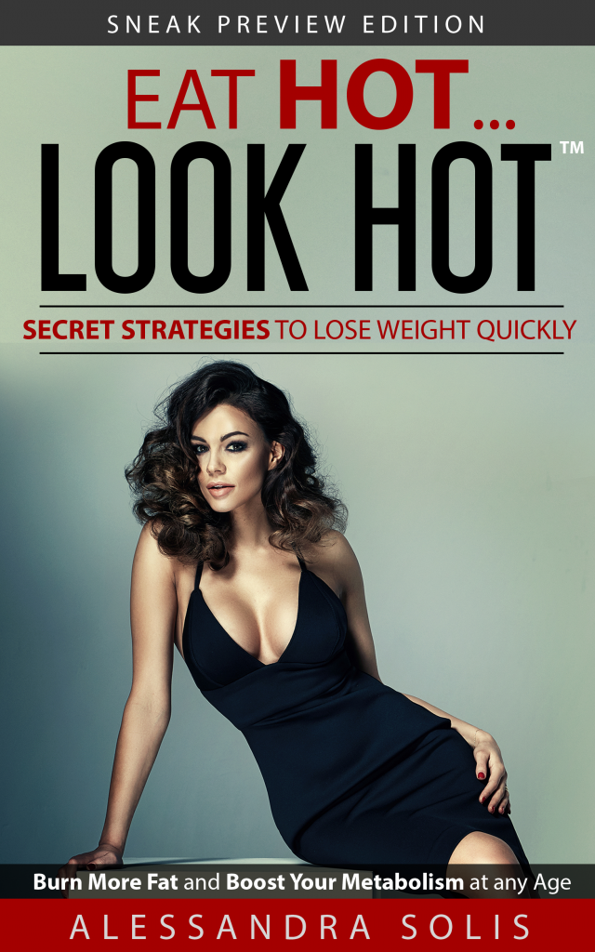
Miraculous Discovery for Weight-Loss Reverses the Widespread Dieting Approach of the Past Century. Revealed to the world in the revolutionary diet book: EAT HOT…LOOK HOT™, Burn More Fat and Boost Your Metabolism at any Age!, by Author and Journalist Alessandra Solis
Miami, Florida, 2017-Nov-27 — /EPR Network/ — Alessandra Solis has unveiled a miraculous discovery that will enable anyone to lose weight quickly. Her proven method helps speed up the metabolism and burn fat at a rapid pace. It also leads to feelings of satiety early in the meal. What makes this theory so astonishing is that it’s inexpensive, and all of the ingredients can be purchased in the convenience of your grocery store. In fact EAT HOT…LOOK HOT’s secret strategies to lose weight quickly relies upon periodic ‘additions’ of certain foods and spices that have fat-busting and metabolism-boosting effects, challenging the prevailing typical weight loss regimen which can be summarized as ‘Eat Less Calories, Exercise More!’
With thousands of people struggling to lose weight, this book is assured to take the world by storm! The information presented in EAT HOT…LOOK HOT is backed by the latest cutting-edge research into food science, and cited within the book to help readers understand how the diet accomplishes its endpoints. The author seeks to share her discovery and novel approach with a world-wide audience, to offer an easier, more sustainable path to weight loss with little modifications to one’s existing meals, drinks, and snacks.
What’s more? There is no exercise component. It’s the addition of the ‘star ingredients’, which the author calls ‘Hot Foods,’ that boost metabolism, burn stubborn white fat, induce feelings of being full, and lead to quick and easy transformative results. It’s an entirely new approach to weight loss that does not surreptitiously restrict calories by one way or another. In fact, there are no deletions required to see dramatic results in a matter of weeks.
Midwest Book Reviewer, Suzie Housley stated “Alessandra Solis is an exceptional author whose book can help a large and diverse population. The research she has conducted and the results she has experienced with this method have convinced me that this book will work for anyone. I feel this book is one of the most beneficial forms of weight loss advice that I have discovered in a very long time. I feel it will quickly become a literary sensation!”
ABOUT:
The author has done extensive research to prove her theory works. Several physicians have endorsed her theory.
“”Superbly researched and presented in a practical, easy-to-implement manner with plenty of bonus materials and guides, EAT HOT…LOOK HOT™ has the power to alter the gold-standard for dieting and permanently transform lives, both physically and psychologically.”
-Brad K. Cohen, MD, F.A.C.S., F.A.A.O.S., Surgeon,
Aventura Orthopedics and Sports Medicine, PA, Miami, Florida
Eat Hot . . .Look Hot is published by Terra Firma Press USA, Inc. and is available for purchase at Amazon.com, Barnes & Nobles, iBooks, Nook, Kobo and Kindle.
ADDITIONAL INFORMATION:
Alessandra Solis presents readers with effective and scientifically-proven weight-loss strategies that she discovered accidentally after altering her diet in just one way and losing 18 pounds in about a month. Following this epiphany, Solis put her research skills – developed by 20 years of experience as a journalist – to work.
To learn more about Alessandra Solis visit her website, www.EatHotLookHotDiet.com
CONTACT:
Alessandra Solis
E-mail: Media@eathotlookhotdiet.com
​Phone: 786-282-9447
#END
Media@EatHotLookHotDiet.com

====
Press release distributed via EPR Network (http://express-press-release.net/submit-press-release.php)

