Open House at Cedarview Rehabilitation and Nursing Care

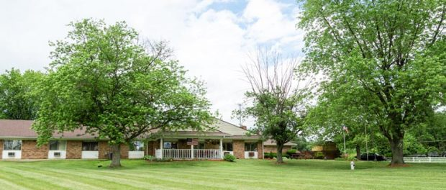

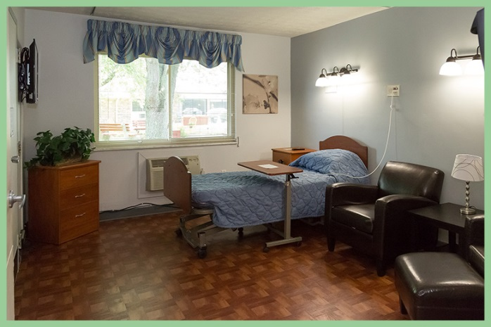 | 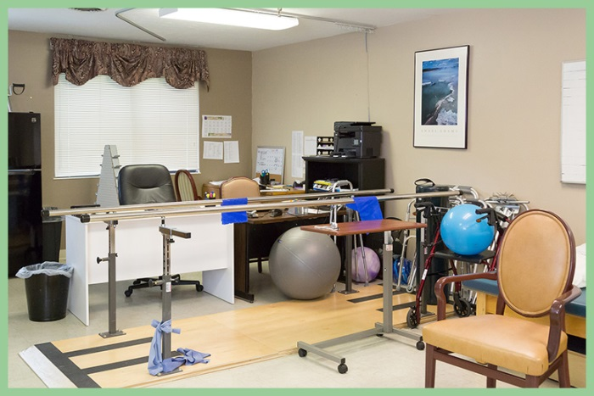

Lebanon, OH, 2017-Dec-01 — /EPR Network/ — Community members and resident families are invited to attend an open house at Cedarview Healthcare Center on Dec. 5th from 5pm-7pm. The guests will be provided a tour of the facility and enjoy music and light refreshments at the event.
“We are all very excited at the facility for the changes and to share these improvements with our residents, the community and employees,” says Elliott Polsky, Administrator of CedarView Healthcare Center.
The renovations to the facility include our updated rehab unit, including a new rehab gym. The rehab unit has 8 private suites. The lobby was completely embellished including new furniture in the lobby and throughout the entire community. Cedarview HealthCare Center is an 83-bed skilled nursing home that caters to the residents of Lebanon.
Cedarview Healthcare Center is a skilled nursing community, located in Lebanon, Ohio, that offers a living alternative for those who need more support than they would receive in their home. The community offers a wide array of health rehabilitation, dietary, and social services for both short term rehabilitation and long-term stays.
Cedarview Healthcare Center has a Pulmonary Unit that is equipped to care for Resident’s with Trach’s, Vent’s and High Flow Oxygen needs. The facility is licensed by the State of Ohio Department of Health, and is staffed with a team that is equipped to meet the individual needs of each resident. Cedarview Healthcare Center is certified by both Medicare and Medicaid.
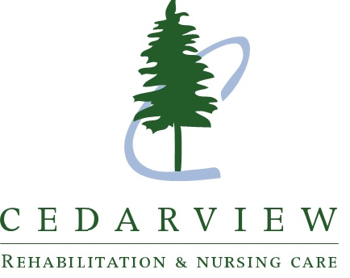
“I think when you visit you’ll be amazed at the modern surroundings and how accommodating the facility is for the residents,” says Lacrisha Crawford, Director of Admissions at Cedarview HealthCare Center.
For more information in regards to Cedarview Healthcare Center Pavilion please call (513) 932-1121 or visit our website at www.cedarviewhc.com.

Press release distributed via EPR Network (http://express-press-release.net/submit-press-release.php)

