New Sasquatch Themed Board Game Unites Believers and Skeptics for hours of fun!

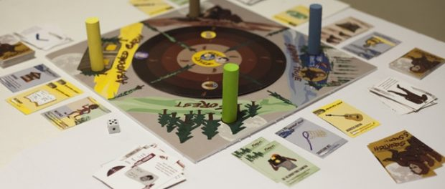
New Sasquatch Themed Board Game Unites Believers and Skeptics
Salt Lake City, UT, 2017-Dec-15 — /EPR Network/ — Cryptolabs, Inc. today announced that Squatch The Board Game, (currently in funding on Kickstarter), will be released for online purchase March 24th, 2018 worldwide via www.catchsasquatch.com.
Squatch is a fast paced table top game designed by a group of 5 designers, engineers, and entrepreneurs, created with gamers of all ages in mind. It’s simplicity allows young players to enjoy it, while the diverse deck and endless outcomes means the more skilled gamers will find themselves happily buried in the game for hours at a time. It features a number of familiar gameplay concepts from classics like Settlers of Catan, presented in an easy to understand format with endless possibilities. The game also boasts never before seen techniques and moves used to reach your final objective. All features interact harmoniously, constructing this addicting game, one you’re sure to come back to game night after game night.
The idea for creating this game was born one night when a group of friends came together for a game night. They enjoyed their games, but wanted to create the perfect game. One they could call their own. Between their various backgrounds of engineering, design, marketing, and entrepreneurship, they realized they could have a lot of fun creating a game that would be all sorts of fun for everybody who played it. They began collaborating immediately, making thousands of revisions along the way, until they ended up with a playful game which includes elements from classic favorites, mixed with unprecedented gameplay elements which add exciting twists and turns along the journey to find and capture the elusive and majestic Sasquatch.
Visit the Kickstarter campaign today to get your copy at a discounted price!
http://kck.st/2zdNF44
Contact-Details:
Squatch Board Game
Jake Andersen
801.897.7656
squatchthegame@gmail.com
http://kck.st/2zdNF44
www.catchsasquatch.com
===

Press release distributed via EPR Network (http://express-press-release.net/submit-press-release.php)

