Racing Towards Retailization: WishKnish and InstantAccess.io Bring Down Usability Barriers to True Blockchain Adoption

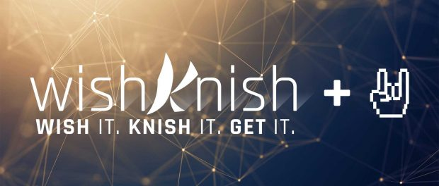
Washington, DC, USA, 2018-Jan-08 — /EPR Network/ — What does the average retail user think about blockchain technology? A few words that frequently come up are: confusing, abstract, scary, complicated, overwhelming. Not exactly wide adoption territory. But one innovative company hopes to change that.
Any great technological revolution goes through stages, each with its own unique challenges. Blockchain technology is still in its infancy, and yet it’s already rearing to change the world. However, before it can “grow up”, it has to be accepted by the harshest audience of all: the average retail consumer.
So, how does one make the average consumer fully understand blockchain tech? If you ask Alisa Gus, CEO of WishKnish (https://wishknish.com) – you don’t.
“When you get into your car in the morning, do you need to understand the principles of internal combustion in order to get your engine revved up? I don’t think so,” Alisa says. “Neither do you need to understand how SSL encryption works in order to make a secure e-commerce purchase. Any great technology has to fit transparently into your routine so that you use it successfully without thinking. That is what needs to happen to blockchain tech before it can be fully embraced.”
WishKnish, the social, gamified marketplace platform startup based out of the Washington, DC area, has been making great strides in bringing much-needed usability improvements to the often complicated process of obtaining and transacting in cryptocurrencies – virtual tokens encrypted using a secret hash and decentralized across multiple distributed “ledgers”.
Last month WishKnish announced a key partnership with UK biometric security firm BioSSL to replace the convoluted and oft-problematic “private key” used to unlock cryptocurrency wallets, with army-grade biometric security measures and other layers of authentication.
Michael Kapoor, former managing partner at Propeller Venture Capital and newly minted COO of WishKnish is no stranger to untangling the usability struggles commonly encountered in this nascent space. “If you’ve ever lost your private key, your tokens are as good as gone,” Mr. Kapoor says. “This level of risk is simply unacceptable for the average user. This is just one example of the evolutionary challenges we are addressing with the WishKnish platform.”
Now, the ambitious team is staring off 2018 by partnering with InstantAccess.io, a usability startup based out of Berlin, Germany that helps users save time filling out form online by maintaining their own private, secure repository that can be easy tapped into with a single click. Previously stored form fields can be updated across the entire network, making changes easy.
“It’s as simple as logging in via Facebook or Twitter – just click the icon, authenticate, and the necessary data will automatically be sent to the app,” explains Eugene Teplitsky, CTO of WishKnish and Alisa’s partner. “Since our goal is to accommodate a wide range of storefront communities, we anticipate a broad need for information that users could potentially exchange with them, from the mundane – like shoe size or dietary preference – to more complex, harder-to-remember details – like blockchain wallet addresses. InstantAccess.io will save users a ton of time, and shave off another layer of usability barriers between blockchain technology and full adoption among retail users.”
“We are super excited about the partnership with WishKnish as we believe blockchain technology is becoming widely adopted by everyday users”, says Rick Chen, director at InstantAccess.io. “Our aim is simple, we want the InstantAccess app to save users time, make their life easier, especially in adopting new and exciting technologies like blockchain.”
The future for retailization of user-facing blockchain marketplaces has never been brighter.
About WishKnish Corp.
WishKnish (https://wishknish.com) offers businesses, affiliates, and non-profits a decentralized marketplace platform for launching gamified, socially-engaged storefront communities equipped with the tools to turn regular users into super-fans and evangelizers while streamlining coin-agnostic e-commerce and fulfillment, as well as offering advanced blockchain-as-a-service tools to meet enterprise clients’ needs.
About InstantAccess.io
InstantAccess is an app that saves all kinds of user information/preferences securely and privately. Users can then re-use this information online and offline with just one click. From emails to shoe sizes to blockchain wallet addresses, InstantAccess makes it easier to access services.
Contact-Details:
WishKnish Corp.,
P.O. Box 2160, Reston,
VA 20195
(202) 800-2663
info@wishknish.com,
https://wishknish.com

Press release distributed via EPR Network (http://express-press-release.net/submit-press-release.php)

