Top Destination of the year is Kenya – The Great Migration

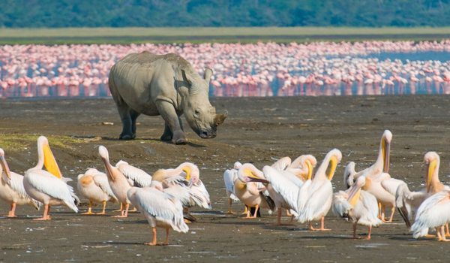
Nairobi, Kenya, 2018-Jan-10 — /EPR Network/ — Priding its self in the world as one of the travel top destinations, most travelers are definitely considering to change their travel trends to visit the African continent and into Kenya who’s capital city is Nairobi.
The top regions where most tourist visit are Nairobi National Park,Masai Mara National Reserve, Lake Nakuru National Park, Mount Kenya, Amboseli National Park, Tsavo East National Park and Tsavo West National Park, Samburu National Reserve, Lake Turkana, Shimba Hills National Park and much more.
With tour operators such as Cruzeiro Safari Kenya coming up with more diverse and pocket friendly tours and safaris, the travel trend will very likely improve and exceed in the year 2018. Factors such as the completion of the political elections which were done and concluded in 2017, Kenya is optimistic to increase its tourist arrivals by massive numbers.
Highlighted are some of the Kenya Safari Packages that Cruzeiro Safaris offers to their travelers
The latest introduced Amboseli Day Trip
Africa Tour for 5 Days to Masai Mara staying at the Base Camp
African Safari to Masai Mara with Ballon Ride for 3 (three)days
Kichwa Tembo Safari from one to any number of days
Governors Camp Safaris for one to any number of days with an option of balloon ride
Serena Safari for 7 (seven) days
Luxury Travel and accommodation to the Mara Intrepids Club in Masai Mara
Amboseli National Park by road for 2 (two) days
Safari Ndovu for 6 (six) days which visits the Amboseli Park, Lake Nakuru Park and Maasai Mara
Another popular road package is the Safari from Nairobi to Mombasa or vice versa for 9 (nine) days most European travelers have made it very popular because it’s also one of the cheap African safari available all over the world.
LIST OF #DAYTOURS
1. https://www.cruzeiro-safaris.com/nairobi-city-tour-lunch
2. https://www.cruzeiro-safaris.com/karen-blixen-giraffe-center
3. https://www.cruzeiro-safaris.com/nairobi-national-park
4. https://www.cruzeiro-safaris.com/bomas – Cultural Tour
5. https://www.cruzeiro-safaris.com/lake-nakuru-national-park – USD220 per person minimum 2 people
6. https://www.cruzeiro-safaris.com/nairobi-park-lunch-karen-girrafe – full day tour USD199 per person – minimum 2 people
7. https://www.cruzeiro-safaris.com/nairobi-tours-/174-carnivore-daily-tour LUNCH OR DINNER plus waiting charges USD75 per person minimum 2 people
8. https://www.cruzeiro-safaris.com/elephant-orphanage-tour -Baby #elephant conservation center in Nairobi where you can #adopt an elephant USD55 per person minimum 2 people
9. https://www.cruzeiro-safaris.com/nairobi-tours-/311-walking-and-cycling-at-hells-gate-park– swimming in the #sulphuric pool, visit the #devils bedroom via the #devilshighway, #rockclimbing and cycling
10. #Masai Mara Safari 2 nights and 3 days. https://www.cruzeiro-safaris.com/masai-mara-safari ; Are you a #group of 6 people we can give you a discounted rate of USD450 per person sharing for low budget lodges.
11. #Amboseli, #Lake Nakuru and Maasai #Mara safari for 5 nights/ 6 days https://www.cruzeiro-safaris.com/safarindovu
12. Safari from Nairobi to Mombasa OR Mombasa to Nairobi for 9 days : Keya Beach and Safari Holiday https://www.cruzeiro-safaris.com/safari-nairobi-mombasa
13. #Aberdres Safari in #Nyeri county for 1 night/2 days https://www.cruzeiro-safaris.com/2-days-aberdares-park
14. #Golf, #Beach and #Bush Safari for 15 days in Kenya ONLY https://www.cruzeiro-safaris.com/golf-and-safari
15. All #4wdrive safari https://www.cruzeiro-safaris.com/10-days-tour-by-jeep for 10 days Samburu / #Bogoria / Nakuru / Maasai Mara
16. #Luxury #lodges safari for #single #travelers for 7 https://www.cruzeiro-safaris.com/single-travel-package to Amboseli, Samburu and Maasai Mara.
17. Kenya Safari Travel Package from Nairobi to Mombasa and vice versa for 9 days – https://www.cruzeiro-safaris.com/safari-nairobi-mombasa
18. https://www.cruzeiro-safaris.com/mount-kenya-sirimon-route-4-day #Climbing #Mount #Kenya
19. #Flying safaris to #Governors Camp in Masai Mara 3 days https://www.cruzeiro-safaris.com/governors-main-camp
20. Flying safari to #Kichwa-Tembo Tented Camp 3 days https://www.cruzeiro-safaris.com/kichwa-tembo-camp
21. Safari for 9 days combining flying and by road https://www.cruzeiro-safaris.com/safaritwiga
22. Adventure safari to #Turkana https://www.cruzeiro-safaris.com/nairobi-safaris/long-safaris/turkana-tours-safari
23. Luxury #Vacation for #honeymooners and #50plus citizen https://www.cruzeiro-safaris.com/50-plus-travel-deal
24. Amboseli National Park Safari for 3 https://www.cruzeiro-safaris.com/3-days-amboseli-park
25. Best Tours and travel Africa package to Zanzibar and Kenya for 9 Days – https://www.cruzeiro-safaris.com/kenya-zanzibar
Cruzeiro-Safaris.com staff and management will be delighted to make your holiday a memorable one!!!
ABOUT US:
Cruzeiro-safaris.com is established in Kenya, incorporated in 2004. Its core business is safari packages and day tours complemented by air travel. It has a well established wealth of experience in arranging memorable tours and safaris and has established a client base who provide with repeat business year after year. Join us on facebook, twitter and youtube. Safaris in Kenya may be tailored to the tourist taste and can extend to Tanzania and Zanzibar.
For further information and reservations, Contact:
Cruzeiro Safaris Kenya | URL: www.cruzeiro-safaris.com |
Email| info@cruzeiro-safaris.com
Tel: +254-722-370833 or +254-710-729021 +254-20-5244333
Mumias South Road, Buru Buru Shopping Center, Visions Place
===
Press release distributed via EPR Network (http://express-press-release.net/submit-press-release.php)

