Publish your novel at a fraction of the cost with Gladiator Publishing Company

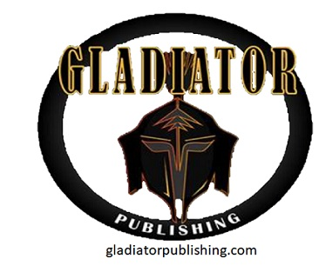

Seneca, Missouri, USA, 2018-Feb-03 — /EPR Network/ — Need your Novel Published but the Prices are too high? Gladiator Publishing Company offers services at a fraction of the cost with a Pay-as-you-go plan fit for any budget.
The field of Self-Publishing has been overpriced for way too long, until now. Gladiator Publishing has vowed to always work for the writer and never against. Double the service for a fraction of the price. Contact one of our Account Managers today for your no-obligation consultation at (challenge-accepted@gladiatorpublishing.com)
Contact-Details:
Gladiator Publishing Company
Albert Kaufmann
417-291-9162

Press release distributed via EPR Network (http://express-press-release.net/submit-press-release.php)

