M. Davis & Sons Provides High-Tech Solutions with Messer Plasma Cutting Equipment

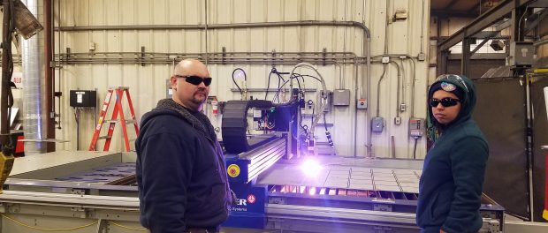
Wilmington, DE, 2018-Feb-20 — /EPR Network/ — Peggy Del Fabbro, CEO of M. Davis & Sons, announced that it has acquired a Messer Cutting Systems Evolution® Plasma Cutting Table. The revolutionary new equipment enables M. Davis and Sons fabrication specialists to produce an enhanced level of smooth edge quality, precision hole cutting, and it keeps the surrounding work area smoke free.
“We are excited to offer the new equipment to advance the customer’s project schedule,” said John Bonk, M. Davis and Sons’ Vice-President of Operations.
The new state-of-the-art plasma cutting equipment by Messer Cutting Systems is software controlled and allows M. Davis & Sons to provide a larger volume of plate cutting in-house to accommodate client needs. The plasma cutting table allows materials to be cut run in measurements from 1.5” for carbon steel to 1-inch for stainless steel and to achieve high-quality edges. Metal plates are aligned to the torch via a camera for extreme accuracy.
One of the most innovative features of the equipment is its smoke-free design. It’s equipped with exhaust dampers that open and close as the welding torch moves for a safer work environment. The Messer Slagger component automatically cleans the machine base with pusher blades for cleaning performed in just minutes for minimal downtime.
The plasma cutting equipment represents the next evolution for steel fabrication and industrial construction. An innovative approach to construction and fabrication enables the company to work faster and produce the highest quality results while providing significant time savings for any project.
The company recently sent two of its fabrication specialists to Wisconsin to receive specialized training and instruction on the equipment’s operation. Additional operators are being trained as part of an ongoing in-house program.
The acquisition of the Messer Cutting Systems Evolution® Plasma Cutting Table by M. Davis & Sons provides the company’s clients in multiple industries with an enhanced level of quality, precision and options for modular process skid fabrication and assembly, steel fabrication, industrial construction and welding.
About M. Davis & Sons, Inc.
M. Davis & Sons, Inc. is a fifth generation women-owned industrial contractor and fabricator located in Delaware that has served customers for more than 145 years in the oil & gas, chemical, pharmaceutical, food, beverage and industrial markets.
Media Contact
Elaine Buonopane
Phone: 302-993-3365
Email: elaine.buonopane@mdavisinc.com
Website: www.mdavisinc.com
Logo:

Press release distributed via EPR Network (http://express-press-release.net/submit-press-release.php)

