APRO CRM: “what?”, “why?” and “when?”

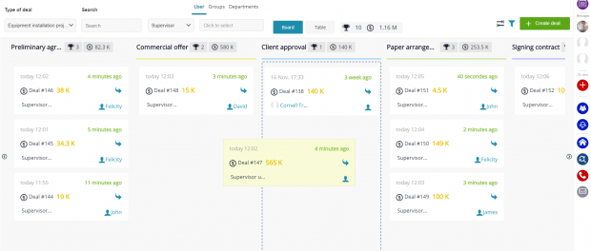
What?
San Francisco, CA, 2018-Mar-27 — /EPR Network/ — APRO CRM is a cloud solution targeted mainly at small and medium enterprises, counting from 1-2 employees up to over 500.
There are ready-made industry solutions for some of the business areas, such as travel, car dealership, legal services, HR, installation, B2B and B2C sales, etc.
Intranet, a built-in corporate portal, provides for live interaction and communication among system users and timely posting of company’s news and announcements.
Why and when?
APRO CRM simplifies your company’s routine processes and activities dramatically, allowing you to call and send emails right from the system, compile profound databases of clients and contracts, assign tasks to your colleagues, manage projects in standard or kanban mode, create detailed reports regardless of their period, and monitor staff activity and tasks progress. Marketing experts will enjoy a whole bunch of special tools, including retargeting, email and SMS campaigns, and statistics.
The main advantage of the system is its ability to adjust to the ever-changing needs of your company as it develops and grows.
Let’s say, your staff counts 3 employees at the moment, and you are perfectly fine with the minimum of features and functions your CRM has to offer. But, in a couple of years your business will grow up to 30 employees or even more. What are you going to do about it? Will you search for another CRM that offers the functions you need now and didn’t require before? Does this sound easy or convenient? — Relax. No bother. APRO CRM functional features can be scaled to fit the specific needs of your business at any stage of its permanent growth. All you need to do is just select and activate new functions that include:
- Telephony. All conversations are recorded. You can create ready-made call processing scripts and connect any telephony provider to your liking.
- Email and SMS campaigns.
- Contact profile containing the history of all interactions with client.
- Sales funnels.
- Automated generation and filling of documents templates.
- Logs.
- Smart marketing tools.
- Library of business processes.
- Cloud file storage.
- Extremely flexible access permissions distribution among system users.
- Integration with company website and client feedback forms (call from website, live chat, callback).
- Integration with social networks.
All this… is only the beginning. The system functions are abundant enough to come out in a series newspaper articles, each dedicated to a new one. Here is another portion:
- Reports and diagrams creator with the option to display current statistics right on your desktop.
- Automated upload of your products to advertising platforms.
- Markers.
- Duplicates search.
- Automated publishing in social networks.
- Any potential integrations via API.
Although the system settings might sometimes require effort, you can always count on getting the best of advice and assistance from our tech support — absolutely for free!
It takes no time to start using APRO CRM — just register, and enjoy the system for two weeks for free! When the trial period expires, you can switch to the rate you find the most appropriate for your company. The minimum rate starts from $19 monthly per user. Our explicit video instructions and attentive tech support will help you familiarize yourself with the system and its functions.
Who?
Mostly small and medium companies, seeking to start using the system as soon as possible, without having to install a private server or hire an IT expert.
FREE TRIAL
Contact-Details: +1 (650) 360-09-10
info@crma.pro
===
Press release distributed via EPR Network (http://express-press-release.net/submit-press-release.php)

