Leading Industrial Contractor and Fabricator Wins ABC National Safety Excellence Award

M. Davis and Sons, Inc. has been awarded the National Safety Excellence Award, which is the industry’s leading safety laurel that honors both merit shop general and specialty contractors.
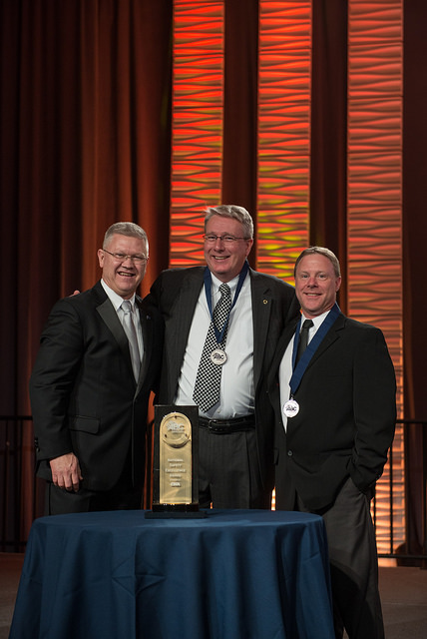
Long Beach, CA, 2018-Mar-30 — /EPR Network/ — Associated Builders and Contractors Delaware Chapter announced the winners of the prestigious Excellence in Construction award during its 28th annual celebration held in Long Beach, California.
The award was received by the construction and fabrication company M. Davis and Sons received amidst resounding applause. M. Davis and Sons. Inc. is the leader in construction and fabrication of corporate plants and facilities for Fortune 500 Companies. Their expertise in mechanical, electrical, fabrication, instrumentation, and power distribution equipment create efficient processes for their customers.
Receiving the award has been termed as a milestone for the company as the Excellence in Construction awards program is the industry’s leading competition that honors both general and specialty contractors for innovative and high-quality merit shop construction projects.
Held on March 26, 2018, the ceremony of the ABC’s 28th Annual Excellence in Construction Awards had guests from every corner of the industry.
Talking to them, the 2018 ABC National Chair George R. Nash. Jr., Director of Preconstruction at Branch & Associates in Herndon, VA said,
“I am continually inspired by the amazing talent these ABC members and their employees display every day in the communities they build. It is an honor to recognize their commitment to world-class safety, superior craftsmanship, and cutting-edge innovation. The scope of this year’s Excellence in Construction award-winning projects, from a science museum and luxury apartment buildings to a polyethylene facility and sports stadiums, proves that if it can be built, the merit shop can be built it, on time and on budget.”
The Associated Builders and Contractors (ABC) organizes Excellence in Construction Awards every year and selects winners based on the several criteria such as experience modification rating, OSHA report information, commitment to safe work practices, policy and leadership, and safety vision.
About ABC:
Associated Builders and Contractors (ABC) is a national construction industry trade association established in 1950. It represents more than 21,000 members. Founded on merit shop philosophy, ABC and its 70 chapters help members develop people, win work, and deliver that work safely, ethically, and profitably for the betterment of the communities in which ABC and its members work. For more information visit ABC.org.
About M. Davis & Sons, Inc.
M. Davis & Sons, Inc. is a fifth generation women-owned industrial contractor and fabricator located in Delaware that has served customers for more than 145 years in the oil & gas, chemical, pharmaceutical, food, beverage and industrial markets.
Media Contact:
M. Davis and Sons
Elaine Buonopane
19 Germay Drive
Wilmington, DE
Phone: 302-993-3365
Email: Elaine.Buonopane@mdavisinc.com
www.mdavisinc.com

Press release distributed via EPR Network (http://express-press-release.net/submit-press-release.php)

