#Nairobi Tours Expand To The Road and Air Packages

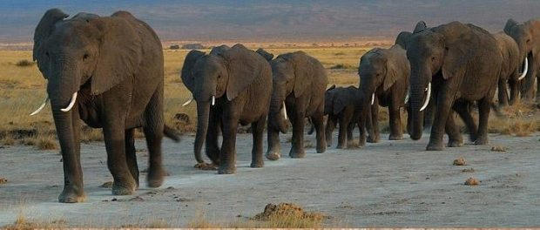
NAIROBI, Kenya, 2018-Apr-06 — /EPR Network/ — It the season of Meetings, Incentives, Exhibitions and Conferences in Kenya. If you are a delegate, trade visitor or Merchant you are most welcome to the land of nature and wildlife. The rising numbers of visitors who travel to Kenya are one way or the other enticed to make a tour around #Nairobi or the surroundings.
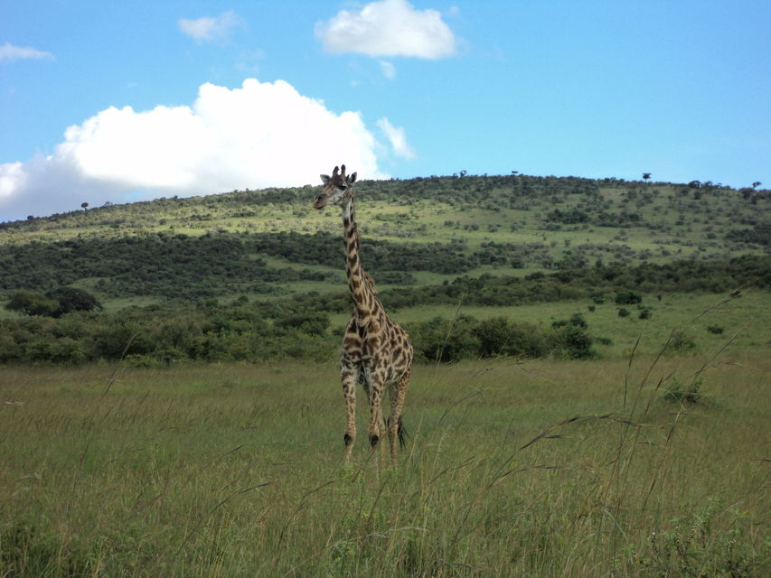
With #CruzeiroSafaris Nairobi Tours Online booking portal one can book easily the #tours they would want on a particular day. The most popular day tours are the Nairobi National Park Tour and The Elephants orphanage and Giraffe Center Tour
LIST OF #DAYTOURS IN NAIROBI
https://cruzeiro-safaris.com/nairobi-tours/
https://cruzeiro-safaris.com/nairobi-tours/nairobi-tours/
LIST OF #AIRPORT TRANSFERS
https://cruzeiro-safaris.com/nairobi-tours/airport-transfers/
LIST OF #SAFARIS BY AIR
https://cruzeiro-safaris.com/nairobi-tours/masai-mara-safaris/
LIST OF #ROAD-TRIPS IN KENYA
https://cruzeiro-safaris.com/nairobi-tours/kenya-safari-packages-by-road/
LIST OF #ZANZIBAR SHORT ANF FULL DAY TOURS
https://cruzeiro-safaris.com/nairobi-tours/zanzibar/
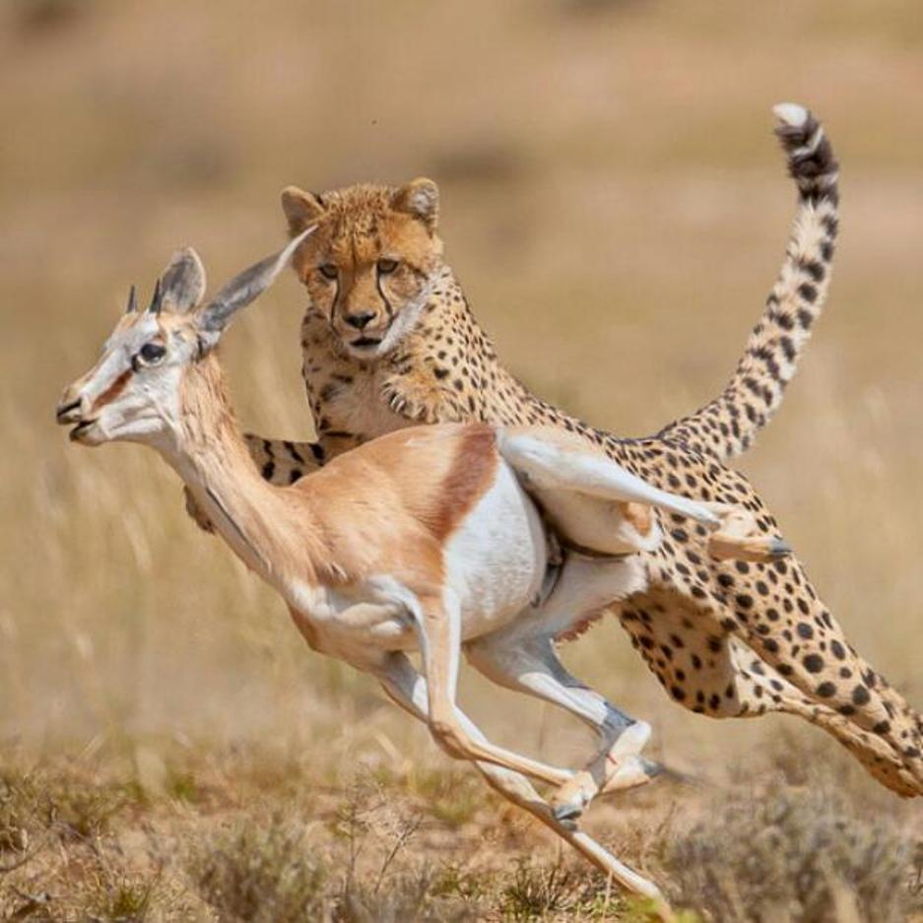
SPECIAL OFFERS
BUDGET CAMPING TRAVEL TO MASAI MARA BY ROAD – BOOKED IN ADVANCE OF 1 MONTH https://cruzeiro-safaris.com/nairobi-tours/product/3-day-masai-mara-2018-wildebeest-migration-kenya-safari/
OTHER KENYA SAFARI ROAD PACAKGES
https://cruzeiro-safaris.com/nairobi-tours/product/2-day-amboseli-trip/
https://cruzeiro-safaris.com/nairobi-tours/product/2-day-tour-to-the-aberdares-national-park-willdife/
https://cruzeiro-safaris.com/nairobi-tours/product/4-day-africa-safari-in-kenya-to-masai-mara-and-lake-nakuru/
https://cruzeiro-safaris.com/nairobi-tours/product/9-day-african-safari-package-nairobi-to-mombasa/
https://cruzeiro-safaris.com/nairobi-tours/product/amboseli-safari-package/
https://cruzeiro-safaris.com/nairobi-tours/product/6-day-amboseli-nakuru-and-masai-mara-safari-game-drives/
Cruzeiro-Safaris.com staff and management will be delighted to make your holiday a memorable one!!!
About cruzeiro-safaris.com
Cruzeiro-safaris.com is established in #Kenya, incorporated in 2004. Its core business is safari packages and day tours complemented by air travel. It is established and with wealth of experience in arranging memorable tours and safaris and has established a client base that provides them with repeat business year after year. One may read traveler’s reviews on their #trip advisor page Cruzeiro Safaris Day tours Nairobi ON Social media network: Follow them on Google+, facebook, twitter or YouTube, blogspot.
For further information, clarifications, queries and reservations, please contact;
Claudia Kabui : Sales and Marketing Director
Email: claudia@cruzeiro-safaris.com |Website: www.cruzeiro-safaris.com
and https://cruzeiro-safaris.com/nairobi-tours
(Kenya) | Mobile: +254-(0) 722-370833 (Kenya)|KATO Full member No.377 – BONDED| Physical address: Mumias South Road, Buruburu Shopping Center, Visions Place, 2nd floor

Press release distributed via EPR Network (http://express-press-release.net/submit-press-release.php)

