**Vital Speeches of the Day Announces 2018 Cicero Speechwriting Award Winners**

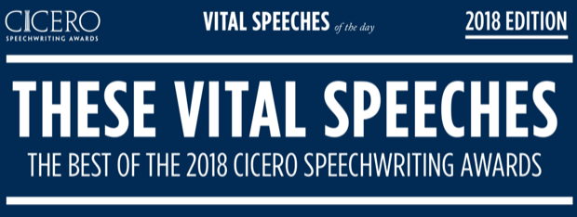

Chicago, IL, 2018-Apr-19 — /EPR Network/ — The editors of [Vital Speeches of The Day](https://www.vsotd.com/) today announced this year’s winners of the Cicero Speechwriting Awards.

Now in its 11th year, the program is presented by the magazine in conjunction with the [Professional Speechwriters Association](https://www.vsotd.com/speech-writers-association), and is open to speechwriters worldwide from any area of the public and private sectors. A panel of speechwriting experts judge entries based on several criteria, including substance, style, and coherence.

The awards go to writers in many categories, including technology, education, healthcare, and public policy, along with one Grand Award winner—the best of the best.

Vital Speeches Editor and Cicero Awards Program Chair David Murray noticed a trend in this year’s submissions: an increase in the use of storytelling.

“Storytelling is a compelling, memorable way to move an audience, said Murray. “In fact, most of this year’s Cicero winners used story to powerful effect—whether as a personal anecdote to connect a speaker to the audience, or, this year’s Grand Award winner, as the structure of the entire speech.”

The Grand award winner, “The Power of Story,” was written by Matthew Kivel and delivered by University of Texas President Gregory L. Fenves. The speech tells the story of the speaker’s father, who survived the Holocaust through both an incredible combination of luck and courage, and lived a life that turned out to be thoroughly worth saving.

“Riveting from start to finish,” said one of the judges of Kivel’s speech. “Raw, powerful, and personal,” said another. “I can’t shake from my mind the images in this speech.”

Storytelling in speeches isn’t new, but it has a new emphasis in speeches now. In a culture awash in electronic communication, people hunger for genuine human connection. “In-person speeches provide an opportunity for speakers to show a live audience their humanity,” said Murray. “Usually, the most compelling and memorable way to do that is by telling a story.”

But always in service of a message. “This isn’t merely a story for the sake of a story,” says University of Texas at Austin’s speechwriter Kivel, who worked with Fenves on the Grand Award-winning speech. “It is a refutation of hatred, an outcry against bigotry, that is meant to resonate during a very troubling time in the history of the United States.”

Such persuasive storytelling pervades the more than two dozen speeches in various categories honored by the 2018 Cicero Speechwriting Awards—all available for [free download](https://www.vsotd.com/sites/default/files/2018_CiceroAwardsWinners_FINAL.pdf) in a collection of winners called These Vital Speeches.

Learn more about the [Cicero Speechwriting Awards](https://www.vsotd.com/cicero-awards).

###

Contact-Details:  
Benjamine Knight  
[psacoo@vsotd.com](mailto:psacoo@vsotd.com)

===

Press release distributed via EPR Network (<http://express-press-release.net/submit-press-release.php>)