Top Tips to Become a Grandmaster

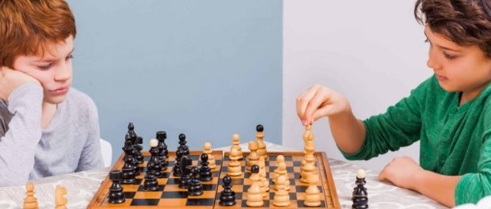

Professional Chess Coach and Author Mato Jelic Shares Top Tips to Become a Grandmaster
Adelaide, South Australia, 2018-Apr-29 — /EPR Network/ — Becoming a Grandmaster is a coveted dream for all chess enthusiasts around the world, but not all of them can make it. Successful coach and popular author Mato Jelic has recently discussed how to become a Grandmaster.
Mato Jelic, a highly experienced professional chess coach and the author or two chess books, has recently shared useful tips to help chess enthusiasts in their pursuit to become a Grandmaster. Mato is the founder of one of the world’s most popular YouTube channels related to chess, through which he offers free online chess lessons.
The World Chess Federation (FIDE) has its own set of guidelines and requirements for becoming a Grandmaster. The players must attend official FIDE tournaments and clinch top positions on at least three occasions to qualify for the process. They should continue to attend such competitions known as norms, until their score reaches the 2,500 mark.
Improving his or her chess skills is undoubtedly the foremost requirement for anyone to become a Grandmaster. According to Mato, this can be accomplished by following the tips mentioned below.
- Learning the tactics: These are the move sequences that can put a player in an advantageous situation and defend or capture pieces. Forks, discovered attacks, and pinning are some of the most important tactics in the game of chess.
- Knowledge of strategies: Once a player reaches the advanced level, they must have a core strategy for each match. Mato also stresses on the importance of strategies such as Nimzo Defense, Sicilian Defense, spacing strategies, and many others.
- Proper execution of endgame situations: A clever endgame strategy is extremely important because a poor endgame can very easily spoil all the previous good work.
- Regular practise: Any aspiring Grandmaster must practice as often as possible against top level players with a thorough understanding of the advanced tactics and strategies. Mato recommends joining a chess club or popular chess sites such as Chess.com
In addition to mastering chess skills, Mato mentions that the different personality traits of an individual can make a serious impact on his or her chances of becoming a Grandmaster. “Ultimately, Passion, inherent talent, competitiveness, discipline, along with a supportive environment, can make all the difference between success and failure,” he says.
A resident of Adelaide, South Australia, Mato is the founder of Chess School SA, a training school that offers chess classes throughout the Adelaide Metro and across the Country Schools in South Australia. He also runs many popular training programs for kids.
To find out more, please visit https://chessschool.com.au/onlinechesslessons/
About Mato Jelic:
Mato Jelic is a highly experienced professional chess coach and the founder/owner of Chess School SA. He is the author of two chess books, and offers free online chess lecture via his YouTube channel that happens to be one of the world’s most popular channels related to chess. Born in Croatia, Mato is now a resident of Adelaide, South Australia.
Contact: admin@chessschool.com.au
Website: https://chessschool.com.au/
https://www.youtube.com/user/MatoJelic

Press release distributed via EPR Network (http://express-press-release.net/submit-press-release.php)

