**Parallax Media Ventures Announces B.C. – BACK TO CIVILIZATION, the first feature film adaptation of the Perennial Classic Comic Strip ‘B.C.’ [Product]**

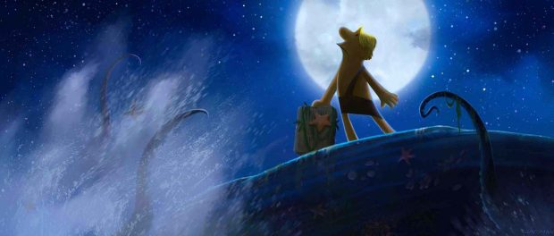

**Parallax Animation Story Team – Including Veterans from Pixar, Disney, DreamWorks, and Illumination – Adapt Classic Comic Strip**

Redwood City, California, USA, 2018-May-09 — /EPR Network/ — Parallax Media Ventures, a leading animation storytelling production company, today announced that it is developing the classic American comic strip, ‘B.C.’ by John Hart Studios as an animated feature film. The team’s pitch reel, featuring storyboard images and concept paintings, will be available for private viewing in May. The feature is a 4-quadrant title Parallax is shoring up for early 2021 release, and currently meeting with potential partners and financiers.

Parallax and Hart Studios will attend the Licensing Expo May 22-24 in Las Vegas to discuss this project with interested parties. To schedule a time to meet and view the pitch reel, please email Kevin Richardson at kevin_richardson@parallaxmedia.ventures

Founded in 2015, Parallax Media Ventures is led by Kevin Richardson, a former executive and senior producer at Nickelodeon, Electronic Arts and Mattel Interactive, and on feature films for leading domestic firms as LucasFilms, Hyperion, Colossal; and abroad at Wang Films Taiwan, MS Films Germany, KingKey Animation China, and most recently Studio Climb Malaysia. Kevin initially became interested in ‘B.C.’ in high school when he produced an animated short on the building of Stonehenge with characters inspired by the strip.

“Today, Johnny Hart’s grandsons Mason and Mick are the wizards behind the daily comic strip,” said Patti Hart of John Hart Studios. “Using their grandfather’s playbook, they take inspiration from trends, headlines, and the politics du-jour and spin them into timeless commentaries and general silliness. We are super excited about seeing B.C. continue its journey onto the big screen. It’s been a great pleasure working with Parallax Media Ventures. Kevin has put together an amazing team and their level of professionalism continues to impress us.”

[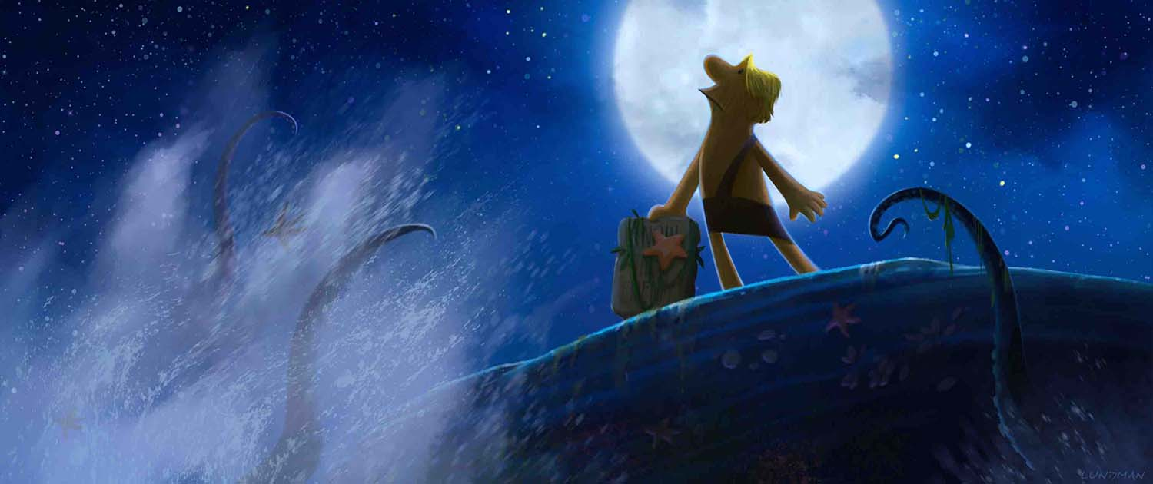](https://express-press-release.net/news/wp-content/uploads/2018/05/B2Civ__night_wave_small.jpg)

“B.C. is an American classic like apple pie and baseball,” said Richardson. “60 years strong, the daily strip runs in over 800 North American newspapers – newspapers with a reach of 64.4 million readers. This gives us a tremendous connection to the fans, and allows us to expand B.C. to an on-screen and off-screen experience. Mason, Mick, and Patti at Hart Studios have helped us understand and blow out the characters – right down to what they eat for breakfast! Thanks to the time-tested and quirky ensemble, there’s no shortage of fun material to work with.”

The Parallax ‘B.C.’ team has collectively worked on 18 animated features, with an aggregate $10 billion USD box office.

**The Parallax ‘B.C.’ team includes:**

* **Julia Lundman** – Julia Lundman is a concept illustrator with over twenty years of experience in the entertainment business. Classically trained, she started her career in commercial animation, art directing commercials and animated shorts, one of which, “Stubble Trubble” was nominated for an Academy Award in 1999. After moving to San Francisco in 2000, she moved into concept art and illustration for games, concept art for Lego, and served as Art Director on Disney’s animated series, “Whisker Haven Tales”, produced at Ghostbot. She was honored to be a finalist in the ILM Art Station worldwide contest in 2015 for key frame concept art.
* **Claus Dzalakowski**, art direction/look development – based in Australia Claus recently opened a facility in India for animation and FX work. Claus has worked on animated features and TV in over 10 countries and has held key positions on several Nickelodeon productions such as Bubbleguppies.
* **Dave Fulp** – Story Artist – 35 years of animation, story, and design experience for projects such as Toy Story 2, Monsters Inc., Finding Nemo, Disney, Pixar, Universal, Warner Bros., Laika, and more.
* **Mike Cachuela** – Story Artist – 30 years of story development experience including classics Nightmare Before Christmas, Toy Story, The Incredibles, and Ratatouille. Instrumental in setting up animation feature studios like LAIKA where he co-directed Coraline.
* **Jim Beihold** – story consultant – more than 16 features in 30 years, including work on Tarzan; The Little Mermaid, and The Chronicles of Narnia: The Lion, The Witch, and the Wardrobe.
* **Jaikumar Balasubramanian** – animation pipe and pre-viz – one of India’s best animation directors and CG pipeline and FX masters, he has worked for Technicolor, Nickelodeon, Disney, and Sony Imageworks.

**ABOUT PARALLAX MEDIA VENTURES**  
Parallax Media Ventures is a boutique global animation storytelling production studio that focuses on early-stage independent feature film properties. Parallax currently has several properties in development, and is comprised of some of the leading animation experts in the industry. Based in Redwood City, California, the company operates using a distributed, virtual, team model. Parallax Media Ventures can be found on the Web at [www.parallaxmedia.ventures](http://www.parallaxmedia.ventures/) and on Twitter at [@ParallaxMV](https://twitter.com/ParallaxMV)

# # #

**EDITOR’S NOTE:** If you would like a photograph of Kevin Richardson, founder of Parallax Media Ventures; Parallax Media Ventures team members, or concept art images from ‘B.C. – BACK TO CIVILIZATION’ please contact Kevin Richardson at kevin_richardson@parallaxmedia.ventures or +1-510-366-8562.  
Parallax Media Ventures is a trademark of Parallax Media Ventures.  
B.C. Copyright and Trademark: © & TM Ida Hart Trust. All Rights Reserved.  
The names of actual companies and products mentioned herein may be the trademarks of their respective owners.

**Contact-Details:** Kevin Richardson  
+1-510-366-8562  
[kevin_richardson@parallaxmedia.ventures](mailto:kevin_richardson@parallaxmedia.ventures)

Press release distributed via EPR Network (<http://express-press-release.net/submit-press-release.php>)