Centres With A Difference
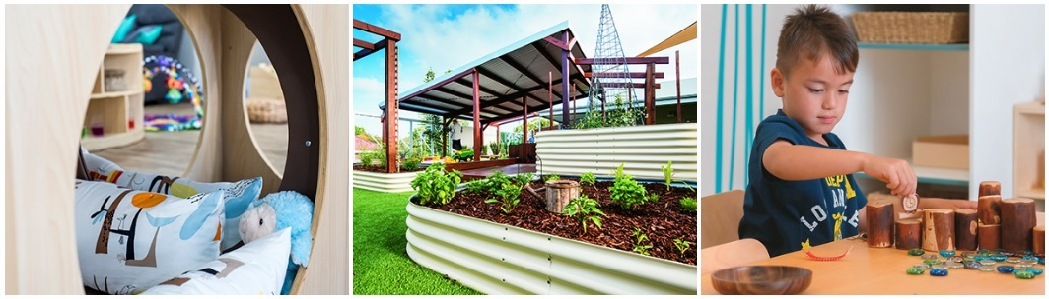
Perth, Australia, 2018-May-31 — /EPR Network/ — Nido Early School centres have established themselves as the benchmark for excellence in early education in Australia and one of the key things setting them apart from other education providers is that they practice what they preach.
Their values and ethos are bound by a passion to provide young minds with the ability, means and skills to enable and sustain future growth and development – and anyone who has experienced this philosophy in action will attest that these aren’t simply hollow words that sound good. The centres really do deliver on their promises.
There are a number of Nido Early School centres in West Australia and Victoria and the company is currently undergoing rapid growth to meet escalating demand for their premium standard of early childhood education.
Their philosophy is inspired by the globally acclaimed Reggio Emilia approach to early education which places significant emphasis on the importance of family and community and which has the premise that ‘it takes a village to raise a child’ at the heart of everything it does.
This emphasis on involving family and community in order to give children the best possible care and education is activated and strengthened in many, many different ways at the centres. But no two centres are the same. Just as each community where the centres are located is unique, each Nido Early School is different and caters for the diverse and ever-evolving needs of children and families.
To meet these needs, a variety of fun and fruitful incursions take place at the centres on an ongoing basis.
These are arranged depending on the needs of the families at the school and the unique community that it serves, and they bring a whole new dimension to early learning. The children get involved in a variety of thought-provoking activities and their young minds are stimulated in a creative, interactive way.
Some recent incursions include visits from a representative from St John Ambulance WA, the local vet, a yoga instructor, a leading nutritionist and a naturopath – all of which brought learning to life in the nurturing and beautiful school environment.
The centres also demonstrate their commitment to the wellbeing of families and the wider community by providing access to essential services like dental care and child healthcare. Take the Nido Early School in the Perth suburb of Lakelands for example which has introduced a monthly visit from a child health nurse to assist busy families and nurture the development of children. Similarly, when the community dental van visits the Nido Early Schools in Perth, they provide important oral health services but they also benefit busy families.
Feedback from the community about these visits has been overwhelmingly positive and the benefits are clear.
Another aspect of Nido Early Schools that makes them ‘centres with a difference’ is their focus on helping those who are in need.
For example, a partnership with a local Dementia Club sees members of the club visiting a Nido centre once a month to share stories, form friendships and learn from one another – and judging by the level of excitement and anticipation about the visits by the children and club members alike, it’s a remarkable experience which benefits everyone. Another example of Nido Early School’s community involvement was a recent sleepout at one of the centres to raise funds and awareness for the St Vincent de Paul Society.
This is just a brief snapshot of some of the many ways that Nido Early School centres activate their educational philosophy and bring learning to life. Each centre is unique, taking its cue from the diverse needs of both the school community and the wider community and meeting those needs through the best possible education and care possible.
For more information on Nido Early Schools, please get in touch through the website www.nidoearlyschool.com.au where you’ll also find the contact details of the centre closest to you.
Contact-Details:
Michelle Carlin
Marketing Director
p (02) 8294 2599
m: 0487 770 488
michelle.carlin@thinkchildcare.com.au
Logo:
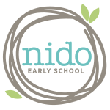
Nido Early School logo
Press release distributed via EPR Network (http://express-press-release.net/submit-press-release.php)

