Corrosion Management For Storage Facilities Using NDT

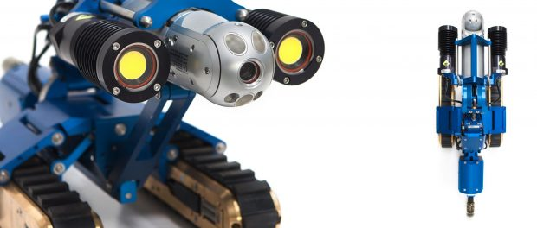
Perth, Western Australia, 2018-Jun-13 — /EPR Network/ — Corrosion is widely accepted as one of the primary causes of degradation and failures in storage tanks.
Many industries including agriculture, general chemical, oil & gas store and energy use above-ground, below-ground, vertical, cylindrical and horizontal tanks to store product with the energy industry in particular exposed to the possibility of corrosion-related issues in their storage facilities. Millions of litres of oil, petrochemicals, liquid gas and other materials are stored in tanks and any failures could have catastrophic results.
Environmental conditions including weather and ground conditions can cause corrosion, but the bulk of the risk emanates from the contents of the storage facilities themselves. Harsh chemicals, contaminants and other corrosive materials which are kept in storage tanks can cause internal corrosion of the metal tanks, pipelines and platforms both on-site and further downstream, with the likelihood of degradation escalating when they’re subjected to constant or regular exposure to corrosive substances.
Controlling and combating corrosion is not only an operational imperative but it’s actually a matter of national security.
Non-destructive testing (NDT) plays a significant role in maintaining the safety and security of assets and infrastructure and NDT technologies together with the development of durable new coatings and other advanced engineering procedures have enabled industries to protect storage facilities against corrosion. For example, metallic and organic coatings and insulation are being applied to tanks and along bond lines as added layers of protection and new non-corrodible materials such as fibreglass are increasingly being used to help minimise the likelihood of corrosion. Engineers are also building secondary containment systems around storage facilities as added protection, plus they are making use of advanced techniques like cathodic protection to further mitigate the risks of corrosion.
Major strides have been made in corrosion-management and whereas engineers used to react to corrosion-related problems, nowadays their approach is a far more preventative one.
Some examples of NDT technologies which play a key role in corrosion-management are:
- Ultrasonic thickness testing which is used to map wall thickness and identify areas of corrosion that may be hidden or difficult to detect, such as in pipework and areas under insulation;
- Eddy current testing to assess the condition of tanks and which can identify potential weaknesses;
- Acoustic emissions testing to monitor the condition of both metallic and fibreglass tanks;
- Thermal testing to isolate areas of potential weakness; and
- Magnetic Flux Leakage (MFL) for testing the integrity of the floor of a container.
Effective inspection of storage facilities through the use of advanced NDT techniques and instruments will identify any areas of degradation or repairs that are required BEFORE any failure occurs. However, accurate and repeatable data is a key element of an effective corrosion-management programme and therefore it is imperative to choose NDT equipment and/or an inspection service provider that delivers the required high performance standards.
Nexxis’s range of NDT equipment and services will provide you with all the highly accurate and comprehensive data that you’ll need to assess the condition of your storage facilities and make informed asset management decisions. Have a look at our extensive range of high quality NDT equipment for sale, lease or purchase on our website, nexxis.com.au or get in touch on 08 9418 4952 and speak to one of our highly experienced technical team. We’re in the business of developing solutions that meet your operation’s individual and changing NDT equipment needs, so talk to us first about your corrosion-management requirements.
Contact-Details: Jason De Silveira
Nexxis
12/55 Erceg Road
Yangebup
Western Australia 6164
Tel: +61-8-9418 4952
Email: admin@nexxis.com.au

Logo:
Nexxis logo
===
Press release distributed via EPR Network (http://express-press-release.net/submit-press-release.php)

