Omnio Lamp is an entire lighting studio in your hands

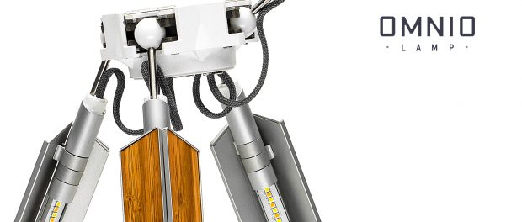
Versatile yet portable, packed with features and made of quality materials, Omnio Lamp is a lamp you will use daily to bring studio level lighting to all levels of photography. Via crowdfunding, the company, Difference Design, is raising funds to finish production and open a new horizon in traditional professional lighting by creating highly effective, yet affordable professional lamps.
Tallinn, Estonia, 2018-Jun-13 — /EPR Network/ — Omnio Lamp (www.omniolamp.com) is a professional lighting studio on the go. The lamp is portable, adaptable, light weight and packed with features, making it an entire studio-on-the-go. Omnio Lamp was unveiled today on Indiegogo and is raising funds for mass production with a goal of delivering highly-effective, yet affordable tool for professional lighting.
Designed with every professional’s needs in mind, the lamp unifies multiple lighting instruments into a single, high quality unit. Like no other lamp, Omnio Lamp has 4 pivoting arms, built-in barn doors, 264 high quality LEDs providing a staggering 4200 Lumens of professional, flicker-free light, and a CRI of 98.9 for skin tones.
Four rotating arms give soft light from four different sides simultaneously. When its barn doors are inverted, each arm gives 2 rays of light in opposite directions: one direct and sharp, and the other reflected and highly diffused, enabling ‘painting’ with light and shadows. Equipped with a standard mounting socket for tripods, holders and hooks, the lamp is designed to be on-the go, adaptable, maneuverable and practical.
“Whether you are a professional or otherwise just a passionate photographer, videographer, blogger, journalist, designer, seller, or an admirer of great design – Omnio Lamp fulfills all of your lighting needs and demands. We created a solution for the common problem of achieving versatility without sacrificing quality,” said Omnio Lamp’s inventor, Branimir Souc. “Omnio Lamp liberates you from multiple light sources and helps you get better results from a single source of light.”
A programmable and intuitive 12-button display enables accurate control of brightness and color temperature with the push of a button. Made of rigid industrial materials and custom electronics, the lamp is light weight, foldable, and easily charged.
The company has tapped into the science of light as a catalyst for innovating an effective and affordable solution for professional lighting. Omnio Lamp cuts the need for multiple lighting sources and covers a range of tasks with one product.
For anything requiring light, Omnio Lamp provides a specific (and perfect) setting: Interview, photo or video shoot, advanced portrait photography, object shoot, reading or working, outdoor filming or beautiful decor.
Professional, multifunctional yet practical and affordable, Omnio Lamp brings a new perspective on how to perceive and use light in photography.
ABOUT Branimir Souc:
Branimir is the founder of Difference Design and inventor of Omnio Lamp, a company focusing on developing smart objects and image based technologies. Branimir is a filmmaker by training, and artist and inventor by occupation. Originally conceived as a compact portrait and item photography lamp, Omnio Lamp has grown to become the most versatile lighting instrument today.
For media materials: https://bit.ly/2HK3653
Contact-Details:
Irina Simin Marinkovich
+16465830373
irina@metodstudio.com or hello@omniolamp.com
www.omniolamp.com / www.metodstudio.com

Press release distributed via EPR Network (http://express-press-release.net/submit-press-release.php)

