Move over HQ Trivia, Fantasy Trivia Live is coming and the world hasn’t seen anything like it yet!!!
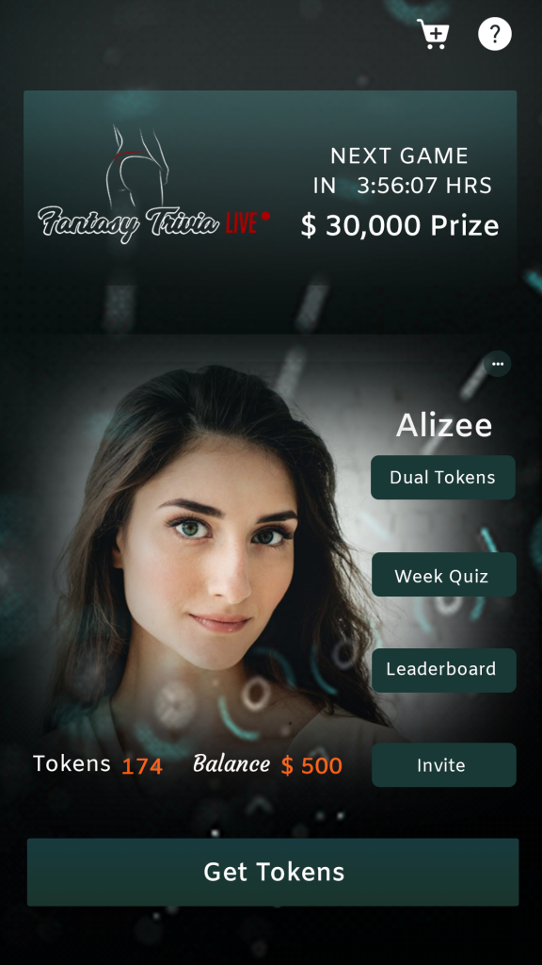
Charlton, MA, 2018-Jul-12 — /EPR Network/ — Mr. Michael Pelletz, Founder and CEO of Fantasy Live Trivia, Inc.
At a glance:
Startup: Yes
Sector: Smartphones, APPs, Technology
Launch Date: October 15th, 2018
Location: Across The Globe
Funding: Yes!!
Problem it solves: Lack of engagement from users of other live trivia apps as well as poor streaming technology that leaves the users frustrated
Website: www.fantasy-trivia.com
1) Could you briefly tell us about the Founders?
Michael Pelletz is a very successful entrepreneur. Michael started a global rideshare company geared towards women safety and empowerment 2 years ago called Chariot For Women, which is now called SAFR that has become the safest rideshare company in the industry. Michael is an expert in turning ideas into reality as well as raising millions of dollars in funds and has some of the best media connections in the US. These skills and connections will ensure the success of Fantasy Trivia Live. Fantasy Trivia Live is his brainchild, and like his rideshare company, he will stop at nothing to make Fantasy Trivia Live the most engaging and profitable App in the industry.
2) How did you come up with the idea? You can share your inspirations
Here is my first inspiration: In February of 2016 I founded a company that is based on women’s empowerment. I have been blessed with a very empathetic heart and soul that allows me to truly resonate with men and women across the globe. Although Fantasy Trivia Live is just a gaming App, I knew once again that I wanted our APP to empower women, and boy will it ever. Our hosts are major celebrities. We are providing a platform for these actors/actresses to flaunt their entrepreneurial spirit in a completely new and safe industry.
Here is my second inspiration:
I was a huge fan of one of our competitors and I was sitting down at my couch watching TV at 8:59 pm, ready to start playing at 9. Then, that 9pm supposed start turned into 9:03 and then 9:04 and then 9:05. I started to get bored. I then glance back at my phone and I notice that the game is finally about to begin. Well….not for me!! It immediately buffered and kept buffering until it kicked me out. I was done with that APP. Within 1 minute of this happening I knew I had to do something better. Fantasy Trivia Live was born. My number 1 priority was to have an app that would stream flawlessly.
3) Brief about your startup
Fantasy Trivia Live is the most engaging adults only Live Trivia App in the world. Our features, which I am not allowed to discuss will truly blow your mind. We are utilizing the most engaging aspects of the most popular Apps currently available. Unlike other Trivia Apps, you don’t have to be good at Trivia to have an opportunity to win lots of cash and prizes. The world is your oyster and you never know what treasures await!!! The user will have opportunities to stay on the Fantasy Trivia Live app day and night, and we have taken every step to make it as visually stimulating as possible.
4) Who are your Targeted audience?
Anyone over the age of 18 who owns a phone. Period!!
5) What type of strategies do you think is valuable to take company to the next level?
I have spent the last 2 years learning what not do when it comes to designing and building a successful and engaging app. Market research is key. Fortunately for Fantasy Trivia Live our competitors have not adjusted to their flaws, which has opened up such a tremendous opportunity to gain control of the Live Trivia market very quickly.
6) Tell us about your amazing team members?
I can’t. LOL!!! Our lawyers will not allow me to say who they are until we are ready. All I can say is, we have the most beautiful, talented and male and female hosts that have tens of millions of followers on social media. It’s unfortunate, but The fans rarely have an opportunity to interact with celebrities live. With Fantasy Trivia Live that will happen almost on a daily basis.
What is the big picture of your company?
Here is our mission statement. This is what Fantasy Trivia Live is all about.
Our mission is to bring together the trivia gaming community and the primary gaming community into a single platform allowing a highly profitable environment to evolve, grow, and develop, leading to multiple and ever expanding profit centers and revenue streams.
What are your future plans?
Make BOAT LOADS of cash, I mean an obscene amount, by and island and retire. Just kidding. I want to live a wonderful life with my beautiful family.
7) What is your best motivation line that inspires you?
GO FORTH AND SET THE WORLD ON FIRE
8) What were the key Learning’s from your journey that you would like to share with our audience?
I could write a book about starting a potential billion dollar company and how lonely that can be. Unfortunately, Greed and Power can get to people’s ego and the people who you thought were your friends are not your friends anymore. Then people enter your life and pretend to be a friend, when all they really want is the power or money. That is probably the hardest lesson I learned from trying to do something very special. Every day I walk around with a smile on my face and hold my head up high and I sleep very soundly at night knowing I would never treat people that way. Life will always throw you lemons and you have to be able to make lemonade, which I am lucky enough to have done throughout my life.
Could you share details about source of funding, revenue, client acquisition model and statistics so far?
That is all internal conversations, but what I can tell you is that raising money is my favourite part of the startup process. If you have a great idea, the money will follow.
9) Your website/app/contact details
Please visit our website at www.fantasy-trivia.com and you will have an opportunity to see our brand ambassador/host. She is truly the biggest gaming nerd I have ever met. That is a huge compliment to her. She is truly brilliant and beautiful on the inside and out!!!
After you answer our Trivia question you will immediately have an opportunity to sign up for our newsletter. We will begin updating this news letter in the coming weeks. Please sign up and get ready for most engaging 18+ Live Trivia App in the industry coming on October 15th, 2018!!
10) Any other information about your startup that you’d like to share with our readers?
Please Tell everyone about us. The more players we have from day one, the more fun it will be and the more money we can give away. A percentage of every purchase from our optional In APP purchases go directly to making the cash prize larger. Get ready for Fantasy Trivia Live!!!
Contact-Details: Fantasy Trivia Live,inc.
42 J Davis Rd, Charlton, MA 01507
508-400-1712
www.fantasy-trivia.com
===

Press release distributed via EPR Network (http://express-press-release.net/submit-press-release.php)

