Spahn & Rose Named to ProSales 100 List

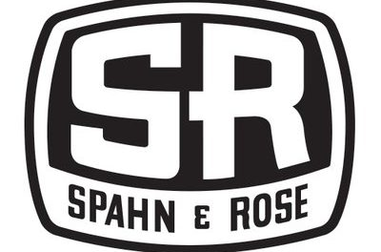
Dubuque, Iowa, 2018-Jul-23 — /EPR Network/ — Spahn & Rose has been named as one of the top 100 lumberyards in the country, according to ProSales, a newsletter that reports on contractor and construction industry trends.
As part of the ranking information, ProSales cited Spahn & Rose as having 85 percent of sales to professional contractors.
Spahn & Rose ranked 56th on the ProSales 100 list based on sales to professional contractors. ProSales compiles the rankings through information provided by listed companies and other publicly available research.
Published annually for the past 26 years, the ProSales 100 is a list of the nation’s biggest building material distributors based on dollar volume of pro contractor sales. ProSales is the newsletter of Hanley Wood, a construction industry research organization.
With 23 locations in Iowa, Illinois and Wisconsin, Spahn & Rose has been serving professional contractors since it opened in 1904.
“We’re proud to be one of the top 100 lumberyards in the country, and Spahn & Rose is dedicated to pro contractor customers,” says Spahn & Rose CEO Dave Davis. “Being recognized on the ProSales 100 is rewarding, and Spahn & Rose will continue to provide contractors with high-quality building materials with top-notch, expert customer service.”
Spahn & Rose is also very active in the communities it serves, during the past three years, the Spahn & Rose Charitable Foundation has donated over $381,000 to a variety of local non-profit organizations.
About Spahn & Rose
Spahn & Rose has been serving the professional contractor since it opened in 1904 and is a leading lumber distributor in the Midwest. With 24 locations throughout Iowa, Illinois and Wisconsin, Spahn & Rose provides high-quality building materials, such as windows, doors, cabinets, drywall, roofing, decking and lumber so that contractors can buy easier and build better.
About ProSales 100 List
The ProSales 100 list is compiled annually by ProSales, a newsletter of Hanley Wood, a research organization focusing on contractors and the construction industry. The ProSales 100 List rankings are based on dollar volume of professional contractor sales. Research for the list is based on information from companies listed along with other publicly available sources.
Contact-Details:
Jacque Arensdorf
Director of Marketing
563.582.3606 x308
jArensdorf@spahnandrose.com
===
Press release distributed via EPR Network (http://express-press-release.net/submit-press-release.php)

