**How to Boost Your Retail Store Profits Absolutely Free?**



**Ecofabrik announces an innovative profit growth program for fashion boutiques and retail apparel stores.**

Oxnard, CA, 2018-Aug-10 — /EPR Network/ — Ecofabrik Organic Gear is introducing a unique partnering for profits co-op program for selected organic apparel boutiques and fashion retail stores. This is a rare opportunity and perhaps a unique concept where Ecofabrik assumes all upfront costs associated with product sourcing/purchasing, importing, and warehousing including shipping and handling of products to their partner resellers. Once the “reseller partner” has been selected and approved, agreed upon earth-friendly products will be placed in their store. All products will be retail ready with hang tags and barcode labels affixed. Retailers will scan and sell the merchandise and pay Ecofabrik once a month for what was sold after deducting a generous percentage of the MSRP as the retailer’s share. Ecofabrik will also pay for the S&H if the retailer needed to return/replace any merchandise. Basically, this is a great opportunity for selected retailers to increase their market share and maximize their profits without risking a dime of their own.

Ecofabrik believes that many organic apparel products made from Bamboo, Hemp, and Organic Cotton are imported into USA from China, India, Bangladesh and other Asian countries. This involves product sourcing, negotiating with foreign suppliers, shipping agents and working with US custom authorities and clearing agents. This is a painstaking process that requires special skills, substantial cash investment and is fraught with supply chain risks. “We have developed in-depth expertise in import business over the past ten years which allows us to bring fair trade, quality products into the US market in an efficient and cost-effective manner,” said Homer Dakaz, a managing partner of Ecofabrik. “We will be extending this competitive advantage to our “reseller partners” to help increase ours & their market share and profitability with zero investment and no risk on their part.”

Ecofabrik’s Marketing Manager; Joe Ecosapien is inviting green businesses to contact him to learn more about this exciting opportunity. While he is very confident about the success of this program, he remains cautious as to how it will be perceived by the business community. “Some store owners will dismiss this outright as a laughably simplistic business model. A few, however, will be willing to give it a go as an excellent business opportunity. We will carefully select only a few like-minded “reseller partners” from each state in the USA to ensure the success of the program. However, a basic requirement of joining the program is to own a brick & mortar store and good standing within the business community of their geographic retail market”, said Joe.

Only green businesses; fashion boutiques and retail stores that sell earth-friendly casual apparel for men and women need to contact. Ecofabrik deals only in products made of organic cotton, bamboo, hemp and other earth-friendly/sustainable fabrics. A collection of these products can be seen at their website; [www.ecofabrik.com](http://www.ecofabrik.com/)

**About Ecofabrik Organic Gear**  
Ecofabrik Organic Gear is a Southern California business dealing in earth-friendly apparel & accessories. Since 2007, the company has been catering to the needs of eco-conscious consumers interested in green living and sustainable life style.

###

Contact-Details:  
Joe Ecosapien; Marketing Manager Phone: [805-487-5308]

Email: [info@ecofabrik.com]  
{ joecosapien@gmail.com}

Homer  
Phone: 805-200-9075

Images:

[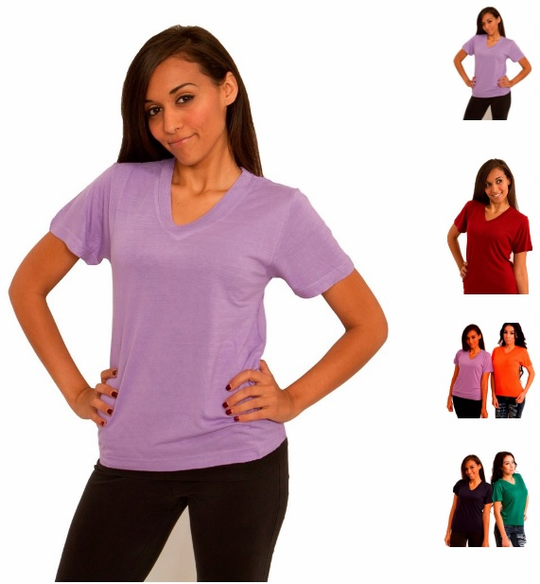](https://express-press-release.net/news/wp-content/uploads/2018/08/ecofabrik-image.jpg)

===

Press release distributed via EPR Network (<http://express-press-release.net/submit-press-release.php>)