**RebatesMe 5th Anniversary, be a smarter online shopper!**

**Our new logo and rebranding are here, beginning a new journey for our company.**

[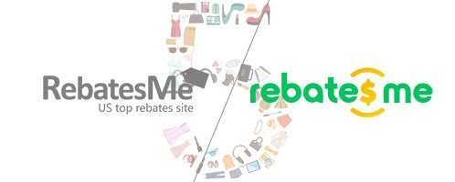](https://express-press-release.net/news/wp-content/uploads/2018/08/pic1-rebatesme.jpg)

Portland, Oregon, 2018-Aug-18 — /EPR Network/ — Online shopping can be described as a great benefit for consumers worldwide. RebatesMe is the ultimate platform that helps shoppers all over the world earn cash back, no matter where you’re shopping from. It is among the top cashback sites offering coupons, discounts, and cash back services. After five years of rapid development, RebatesMe has brought global high-quality and cost-effective products to more than one million consumers from China and the United States, and now to the whole world. And its global brand influence is growing.

Striving to meet the needs of this change and to aid in future development strategy, RebatesMe officially launched the new logo on our 5th anniversary in efforts to further enhance the brand image and to continue upgrading its brand and service.

In the face of fierce consumer competition, economic benefits and good service are undoubtedly the two keys to winning the market. The new brand image is upgraded to link the brand value with the consumer demand. RebatesMe brings higher cashback to consumers and provides users with a better shopping experience.

RebatesMe has always been involved in overseas cash back shopping and has been actively cultivating the US market for many years all while continually expanding global business cooperation in Europe, Asia, and Oceania. All while still striving to accelerate the globalization of overseas shopping and consumer cash back. By expanding our overseas merchants, categorizing products and providing exceptional shopping tips, we are able to provide our shoppers both in the US and china with a more extensive choice of products with cash back.

At present, RebatesMe has cooperated with more than 3,000 merchants around the world. At RebatesMe, you can get the latest international e-commerce preferential information and enjoy the best-selling products globally. In addition, loyal users with VIP membership can also enjoy preferential treatment by learning about exclusive deals in advance, paired with our superior customer service, giving them an overall better experience in global online shopping.

In the past five years, RebatesMe has earned millions of dollars in cashback for its website users. And now on its 5th anniversary, RebatesMe will continue to be an unparalleled contender in e-commerce shopping around the world and excitedly anticipate a surge in growth with our rebranded image.

[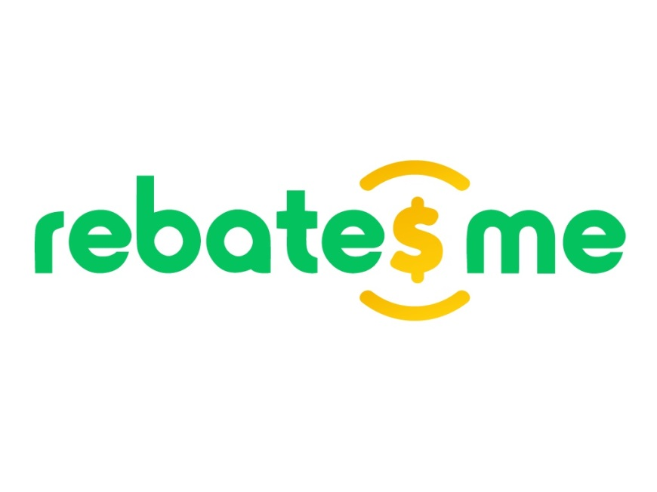](https://express-press-release.net/news/wp-content/uploads/2018/08/pic2-rebatesme.jpg)

Related Link: <http://www.rebatesme.com/?d=20416>

Media contact:  
RebatesMe, Angel Gao, 503-719-4367, [angel.gao@rebatesme.com](mailto:angel.gao@rebatesme.com)

===

Press release distributed via EPR Network (<http://express-press-release.net/submit-press-release.php>)