Hughes Candles Announces Unisex Wood Wick Soy Candle Grand Opening Launch

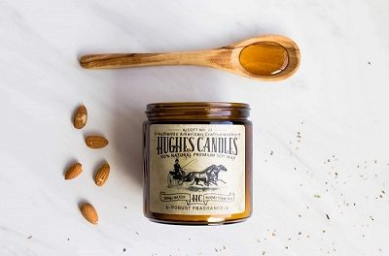
Broken Arrow, OK, USA, 2018-Aug-18 — /EPR Network/ — Hughes Candles, an Oklahoma artisan home fragrance manufacturer announces their grand opening and launch of their original collection of unisex wood wick soy candles.
“We feel like this launch has been a tremendous success, customers are providing raving reviews, and we have already established two new retail partnerships–one in Tulsa, OK and one in Claremore, OK soon to be announced. We couldn’t be happier with our progress and we are looking forward to establishing additional retail partnerships across the state of Oklahoma, and surrounding states,” said, Jason Oelrich II, President.
About Hughes Candles
Hughes Candles are an artisan, hand poured, small batch, all-natural, unisex, wood wick, soy candles infused with beautifully complex and sophisticated fragrances, that showcase stunning burn pools when lit, making the candles essentially maintenance free and a healthier option than traditional candle alternatives.
Hughes Candles Classic Wood Wick Soy Candle Collection
Alcott No. 23- Fragrance: Nostalgic, romantic, exotic, smooth and spicy
Steinbeck No. 28- Fragrance: Smoky, woody, spicy
Thoreau No. 27- Fragrance: Fresh and woody
Whitman No. 26- Fragrance: Crisp, woody, evergreen
Emerson No. 29- Fragrance: Fresh and invigorating
Longfellow No. 24-Fragrance: Clean, cool, spicy.
Proudly handmade in Broken Arrow, Oklahoma, USA
To learn more about Hughes Candles and see our entire classic collection of wood wick soy candles visit: https://hughescandles.com
To explore a wholesale relationship with Hughes Candles, visit: https://hughescandles.com/pages/contact
Media contact:
Hughes Candles
Jason Oelrich II, President
2608 W. Kenosha St. Suite. 507
Broken Arrow, OK, 74012
===
Press release distributed via EPR Network (http://express-press-release.net/submit-press-release.php)

