Top Tour Day Trips Picks from Nairobi

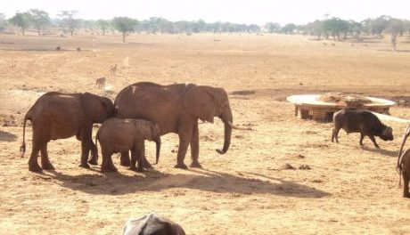
Nairobi, Kenya, 2018-Sep-13 — /EPR Network/ —
Lake Naivasha and Crescent Island Tour
Naivasha has become an agricultural back water that now exists primarily to service the area’s blossoming with flower industry
For many people Lake Naivasha is the first port of call after Nairobi and with its shores fringed in papyrus and yellow backed acacias, bulbous snorting hippos playing in the shallows, a cacophony of twittering birds and gentle climate, there is no denying its appeal over the urban mayhem of Nairobi not only does lake Naivasha’s fresh water bestow it with unique ecosystem (in comparison with the other Rift Valley lakes, while are highly alkaline) but it also means the lake can be used for irrigation purposes. Lake Niavasha is now the centre of Kenya’s Millions flower industry. The lakes ecology has been interfered with on a number of occasions, notably with the introduction of foreign fish for sports and commercial fisheries. For these reasons and others Naivasha has been the focus for conservation efforts. Despite all that Nairobi people flock the lake every weekend. With plenty of things to see, a fun loving atmosphere and in the still morning mists and undeniable beauty. Lake Naivasha remains the best place to get grips with being in Kenya.
Crescent Island wildlife Sanctuary
The protruding rim collapsed volcanic crater forms this Island on the eastern side of Lake Naivasha. It’s a private sanctuary where you can walk beneath the acacia in search of giraffes, Thompson and Grants gazelles, elands, water bucks and countless bird species.
Elsamere Conservation Centre
This conservation centre is the former home of the late Joy Adamson of Born Free Fame. She bought the house in 1967 with a view of retiring here with her husband, George. Adamson did much of her writing from Eslamere, right up until her murder. Now a conservation centre focused on lake ecology and environmental awareness programs, a visit to the memorial room and a showing of the withered 40 minutes Joy Adamson Story.
One can book a day tour from Nairobi City to visit Lake Naivasha, the conservation centre, visit the crescent Island on a boat ride from Elsamere, have lunch and watch the video and return to Nairobi
Book The Lake Naivasha Tour to Elsamere and Crescent Island Tour Today online on https://cruzeiro-safaris.com/nairobi-tours/product/lake-naivasha-tour-with-crescent-island/
Others Full Day Tours to Consider from Nairobi include
Full day Trip to Amboseli national park
Full day Tour to Lake Nakuru National park
Full Day Tour in Nairobi to Nairobi National Park, Elephants Orphanage, Lunch and Giraffe Center
Option Starts at 6am
Option Starts at 10am
About Cruzeiro Safaris Kenya
Cruzeiro-safaris.com is established in Kenya, incorporated in 2004. Its core business is safari
packages and day tours complemented by air travel. It has a well-established wealth of experience in arranging memorable tours and safaris and has established a client base who provide with repeat business year after year. Join us on facebook, twitter and youtube. Safaris in Kenya may be tailored to the tourist taste and can extend to Tanzania and Uganda.
Contact-Details: For further information and reservations, Contact;
Claudia Kabui
Mobile Sales : +254-(0) 722-370833 (Kenya)
Operations : + 254 (0) 710-729021 (Kenya)
Email: info@cruzeiro-safaris.com
Website: | https://www.cruzeiro-safaris.com and https://cruzeiro-safaris.com/nairobi-tours/

Press release distributed via EPR Network (http://express-press-release.net/submit-press-release.php)

