THIRD BOOK OF VERSE FROM THE PEOPLE’S POET MICK COLLISS
Perth, Australia, 2018-Sep-20 — /EPR Network/ — Mick Colliss has delivered his poems all over the world. From Centre Court at Rod Laver Arena, to Olympic athlete functions, to audiences in the United States.
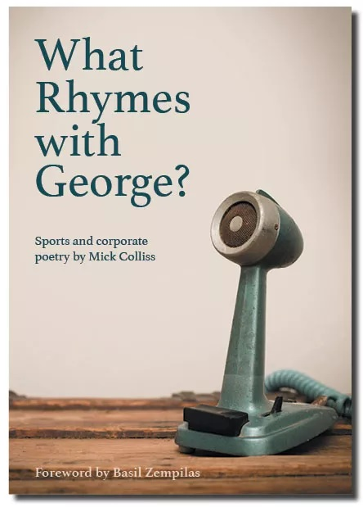
Now the author, poet, guest speaker, commentator and former vice-captain of the Australian Sudoku team has released a new collection of verse – his third.
His poems are dry, funny, occasionally moving and uniquely Australian.
Titled What Rhymes with George? his book contains over 40 different poems written over the past 10 years and covers a range of sports, occasions and anecdotes as well as tributes to individuals including Dennis Commetti, former Wallaby Nathan Sharpe and events like the San Jose copper mine rescue and the devastating Queensland flood.
“In 2003 the West Coast Eagles asked me to write a poem to commemorate Glen Jakovich’s 250th game,” Colliss said. “My first thought was: what rhymes with Jakovich?”, which became the title of my first book. I took it in to Radio 6PR in Perth and gave a copy to the legendary broadcaster, George Grljusich. He looked at the title and answered “Grljusich”.
“I thought of calling this book What Rhymes with Grljusich? in honour of the great man but thought it would be too hard to find on Google, so called it What Rhymes with George? instead.
“It’s much easier to spell.”
Colliss has been writing his unique form of poetry for many years and his work has appeared in The Sydney Morning Herald, The Sunday Times, Australian Rugby News and The West Australian. He has written on request for organisations including the West Coast Eagles, the WA Olympic Committee, the WACA, Western Force, Fremantle Dockers and Ronald McDonald House.
The foreword of What Rhymes with George? has been written by Basil Zempilas, most notably of Channel 7 and Radio 6PR.
Mick’s most recent commissioning was to write a poem for Tennis Australia, which he performed on centre court at Rod Laver Arena – with luminaries such as Martina Navratilova, Billie Jean King, Frank Sedgman and Laver himself standing alongside – during the 2018 Australian Tennis Open.
What Rhymes with George? is available at selected outlets and online at https://www.whatrhymeswithgeorge.com
Colliss is available for all media and interviews. Contact Mick Colliss on 0409 090 290 or by email at mick@mickcolliss.com
===
Press release distributed via EPR Network (http://express-press-release.net/submit-press-release.php)

