Travel to Kenya – Global Tourists Prefer Private Conservancies Prioritizing Conservation, Luxury and Privacy

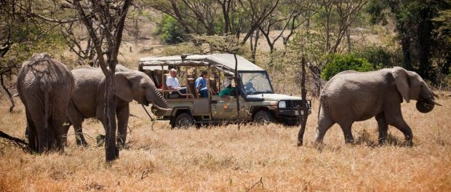
Nairobi, Kenya, 2018-Sep-20 — /EPR Network/ — The Masai Mara has fuelled African fantasies for years and without the shadow of a doubt, its wildebeest-spotted savannahs are the attractions of what a star-studded region as it became one of the wonders of the world.
Dream of Africa and you dream of the Masai Mara. This huge expanse of gently rolling grassland, specked with flat-top acacia trees and trampled by thousands strong herds of zebra and wildebeest, is the ultimate African Cliché’ But for one reality lives up to the image and form many people this reserve is not just the highlight of their Kenyan adventure but the very reason they came.
How to get there: Preferably by flights. Flights to masai Mara are daily in the morning and evening and return the same timings. Park entry fees are limited to a 24 hour stay. Whether you’re bouncing over the plains in pursuit of elusive elephant silhouettes or parked next to a pride of lions and listening to their bellowed breaths, wildlife drives are the highlight of a trip to the Mara. All top-end places offer wildlife drives, some offer night game drives as well as walking safari for about 1 hour mostly in the morning weather permitting.
Although concentrations of wildlife are typically highest in swampy areas around the escarpment on the reserve of the western edge, superior roads draw most visitors to the eastern side. Of the big cats, sandy eyed lions are found in large prides everywhere, and it’s not uncommon to see them hunting. Cheetahs and leopards are less visible but still fairly common elephants, buffaloes, zebras and numerous other grazers occur in quantities that boggle the mind. For most people Kenya means viewing many animals.
The Big five wildlife includes Lion, Buffalo, Elephant, Leopard and Rhino. In addition to the Big Five we have the Little Five that include Elephant shrews, Ant lions, Leopard Tortoise, Buffalo weavers and Rhino Beetles.
Private lodges, Luxury tented camps and even fly-in camps are used in top-end safaris, all with the aim of providing guests with as authentic and personal bush experience as possible without forgoing the creature comforts. Even in the remote settings without running water you will be able to enjoy hot, bush style showers, comfortable beds and fine dining. Also expect a high level of personalised attentions and intimate atmosphere- many places at this level have fewer than 20 beds. Cruzeiro Safaris Kenya has selected among the tented camps in Masai Mara that offer high end services and experiences.
One can book online or contact through the contact form to enquire more.
Bookings accepted for 1st October to 20 December, 2018.
Eagle View and Leopard Hill at Naibosho conservancy.
https://cruzeiro-safaris.com/nairobi-tours/product/masai-mara-3-days-safari-air/
Bookings accepted for 2019-2020
Eagle View Camp in Naibosho Conservancy
https://cruzeiro-safaris.com/nairobi-tours/product/3-days-in-maasai-mara-experience-kenya-by-air/
Samburu National reserve and Masai Mara for 5 Days in Luxury Accommodation
https://cruzeiro-safaris.com/nairobi-tours/product/5-day-kenya-luxury-safari-to-samburu-masai-mara-africa/
Masai Mara Safari for 5 Days – Escape The Crowds
https://cruzeiro-safaris.com/nairobi-tours/product/escape-to-africa-masai-mara/
Governors Camp for 2 Days only
https://cruzeiro-safaris.com/nairobi-tours/product/governors-camp-safaris-from-nairobi/
Other Places inside the Masai Mara national Reserve
Bookings accepted for year 2019 to 2020 –
Accommodation at Keekorok Lodge inside Masai Mara
https://cruzeiro-safaris.com/nairobi-tours/product/masai-mara-safari-from-nairobi/
Kenya Safari Packages by Road
https://cruzeiro-safaris.com/nairobi-tours/kenya-safari-packages-by-road/
Other Nairobi Full day Tours
Full Day Amboseli Day Trip https://cruzeiro-safaris.com/nairobi-tours/product/full-day-safari-tour-to-amboseli-national-park-from-nairobi/
Lake Nakuru Day Trip https://cruzeiro-safaris.com/nairobi-tours/product/full-day-tour-to-lake-nakuru-national-park/
Nairobi National Park, Elephant Orphanage, Giraffe Center and Lunch
https://cruzeiro-safaris.com/nairobi-tours/product/nairobi-national-park-tour-elephants-orphanage-giraffe-center-and-lunch/
About Cruzeiro Safaris Kenya
Cruzeiro-safaris.com is established in Kenya, incorporated in 2004. Its core business is Safari Packages and Day Tours complemented by air travel. It has a well-established wealth of experience in arranging memorable tours and safaris and has established a client base who provide with repeat business year after year. Join us on facebook, twitter and youtube. Safaris in Kenya may be tailored to the tourist taste and can extend to Tanzania and Uganda.
For further information and reservations, Contact;
Claudia Kabui
Mobile Sales : +254-(0) 722-370833 (Kenya)
Operations : + 254 (0) 710-729021 (Kenya)
Email: info@cruzeiro-safaris.com
Website: | https://www.cruzeiro-safaris.com and https://cruzeiro-safaris.com/nairobi-tours/
===
Press release distributed via EPR Network (http://express-press-release.net/submit-press-release.php)

