**Ellen London to Showcase Spring Summer 2019 Wearable Art collection at International Couture Runway DC Fashion Week on September 23**

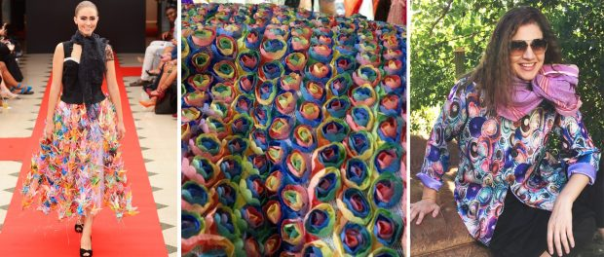

Washington, D. C., 2018-Sep-24 — /EPR Network/ — With the introduction of her printemps/été 2019, Ellen London strives through her wearable art collection to emerge from the daily complex incongruities we experience and to rise from the ground with beauty and grace as does a flower – “de la sol une fleur doit grandir”.

Her collection challenges the audience to emerge with hope and possibilities from the shadowy confines of our internal and external walls, and to work towards inclusion rather than exclusion. Focusing on connection, understanding and respect, Ellen London translates these ideas through fabric art – utilizing vintage and new – textiles and techniques – from a myriad of global cultures and countries. Hand painted cities on palettes of silk, and designer felted pieces interpreting color and light are highlights of the collection.

The ellenlondon Studio SS2019 collection previews at the finale International Couture Runway at DC Fashion Week runway on September 23 2018.

Contact-Details:  
Ellen London  
info@ellenlondonstudio.com  
[www.ellenlondonstudio.com](http://www.ellenlondonstudio.com/)

Logo:

[](https://express-press-release.net/news/wp-content/uploads/2018/09/ellenlondon-logo-sm2.png)

**Ellen London logo**

Press release distributed via EPR Network (<http://express-press-release.net/submit-press-release.php>)