Flights to Nairobi Kenya from New York USA makes trips and travel planning pleasurable

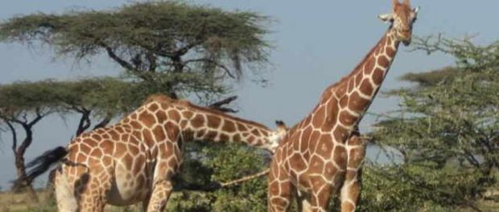
Nairobi, Kenya, 2018-Oct-09 — /EPR Network/ — Kenya Airways the official carrier of the Republic of Kenya will from October 2018 commence flights from New York, USA to Nairobi, Kenya. This is a welcome move in the travel and tourism industry in Kenya that is intended to see an increase of tourist and business travellers moving across the 2 continents with ease. Kenya being a hub of conferences and tourism landmark destination awaits with enthusiasm to increase arrivals which in turn increase the GDP of the country especially in tourist earnings.
Kenya is a country equally for thrill seekers, sun seekers and high –end rollers, those who like it tough and those who just want to get going. Whatever you want to do here, you’ll discover that it’s pretty straight forward to sort yourself out and in many cases, more reliable to make advance plans with local tour operators such as Cruzeiro Safaris Kenya.
This is a well resourceful tour operator company with their main information site https://www.cruzeiro-safaris.com and their online booking site https://cruzeiro-safaris.com/nairobi-tours
Some of the tours they offer in Nairobi are Nairobi National Park, Nairobi City Tour, Elephant Orphanage Tour, Giraffe Center Tour, Lake Nakuru national Park tour, Amboseli national Park Tour, Tours to Chimpanzee and rhino sanctuary and more tours.
Some of the overnight safaris they offer are only related to Luxury travel lodges and one fly’s by Air (Safaris by Air). The destinations include Masai Mara Safari, Amboseli Park, Malindi – Watamu, Mombasa, Samburu Reserve and Meru National park.
Airport Transfers in Nairobi are also available on their online platform.
When to go to Kenya
The main tourist season is in January and February, when weather is hottest and driest. At this time animals in the wildlife parks tend to congregate more around the watercourses, making them easier to sort.
From June to October, the annual wildebeest migration takes place, with thousands of animals streaming into the Masai Mara National reserve from the Serengeti. However, the parks can get crowded and rates for accommodation soar also make sure you avoid Christmas and Easter unless you want to pay much higher prices.
During the long rains (the low season, spanning from March to the end of May) things are much quieter. Wildlife is harder to spot except perhaps only for the Nairobi National Park located within the capital city. The recent visit by First Lady of the United States (FLOTUS) hosted by First Lady of Kenya (FLOK) to the Nairobi National Park and The Elephant Orphanage in Nairobi showcased Kenya’s effort in conservation matters for sustainable development. Once can book a direct tour with Cruzeiro Safari to the 2 Places through the following link https://cruzeiro-safaris.com/nairobi-tours/product/nairobi-national-park-tour-and-elephants-orphanage/
And if one has more time they could also add the giraffe centre to the mix as follows https://cruzeiro-safaris.com/nairobi-tours/product/nairobi-national-park-tour-elephants-orphanage-and-giraffe-center/
And with lunch too https://cruzeiro-safaris.com/nairobi-tours/product/nairobi-national-park-tour-elephants-orphanage-giraffe-center-and-lunch/
Startingat 10am option: https://cruzeiro-safaris.com/nairobi-tours/product/tour-to-elephants-giraffe-and-nairobi-national-park/
The best time to see wildlife is between 6.30am and 9.30am, and from 3.30pm and 6.30pm. Make sure your safari company takes you out during these times. Wildlife drives in the middle of the day are unlikely to turn up much, although these signs that in the popular parks (such as Amboseli and Masai Mara), animals are actually changing their normal hunting habits to avoid the tourists. When the tourists head back to the lodges for lunch, the carnivores go out hunting –in peace.
Travelling in Kenya can cost as much or as little as you like, depending on what kind of standards you’re happy with. The continuous growth of the travel industry and the commencing of direct flights to New York from Nairobi are anticipated to bring incredible economic success.
About Cruzeiro Safaris Kenya
Cruzeiro-safaris.com is established in Kenya, incorporated in 2004. Its core business is Safari Packages and Day Tours complemented by air travel. It has a well-established wealth of experience in arranging memorable tours and safaris and has established a client base who provide with repeat business year after year. Join us on facebook, twitter and youtube. Safaris in Kenya may be tailored to the tourist taste and can extend to Tanzania and Uganda.
About Cruzeiro Safaris Kenya
Cruzeiro-safaris.com is established in Kenya, incorporated in 2004. Its core business is Safari Packages and Day Tours complemented by air travel. It has a well-established wealth of experience in arranging memorable tours and safaris and has established a client base who provide with repeat business year after year. Join us on facebook, twitter and youtube. Safaris in Kenya may be tailored to the tourist taste and can extend to Tanzania and Uganda.
For further information and reservations, Contact;
Claudia Kabui
Mobile Sales : +254722370833 (Kenya)
Operations : + 254710729021 (Kenya)
Email: info@cruzeiro-safaris.com
Website: | https://www.cruzeiro-safaris.com and https://cruzeiro-safaris.com/nairobi-tours/

Press release distributed via EPR Network (http://express-press-release.net/submit-press-release.php)

