**Just For Diabetics Website Offers Hope for Pre-diabetics, Type 2 diabetics, and the Overweight**



***Research shows that the best time to take action to reverse pre-diabetes and type 2 diabetes is when you are at the stage of managing these conditions.***

Vancouver, BC, Canada, 2018-Nov-06 — /EPR Network/ — November is world diabetes month. When people are diagnosed type 2 diabetic, the first line of defense is the use of prescription drugs in order to manage the diabetes. But what victims of pre-diabetes and type 2 diabetes are not aware of is that research performed by [Just **For Diabetics website**](https://justfordiabetics.com/) founder, Ernest Quansah, shows that when patients are managing their pre-diabetes or type 2 diabetes, it is the best opportunity for them to reverse it and be weaned off the prescription drugs. The research results are evidence based. Many doctors and institutions now agree that this is the case. Recently, the University of British Columbia, in conjunction with Pharmasave, a drugstore chain, began offering obese people and type 2 diabetics a diet plan aimed at reversal of pre-diabetes and type 2 diabetes. The cost of their plan is $500 a month. The diet plan calls for no consumption of refined sugar, potatoes, fruit, fruit juices, sweet drinks of any kind, rice, bread, and consumption of cooked vegetables for lunch, cooked chicken breast for dinner and so on. Many of the participants are seniors, the overweight, or obese. After several thousand of dollars spent, many participants lose weight and their doctors take them off their diabetes drugs.

Quansah’s program includes a specialized diabetes exercise regime along with vitamin therapy and a carefully designed tasty menu cycle. He himself completely reversed his severe case of type 2 diabetes after compiling this program, which was the culmination of thorough research. This research included the advice of several physicians. Quansah, founder of [**Just For Diabetics**](https://justfordiabetics.com/) and the author of ***Diabetics Journey*** says: “For several years, I have been educating people about how type 2 diabetes and pre-diabetes can be reversed through the program offered on my website. Now we see that one of Canada’s finest Universities and a drug store chain are doing the same.”

The website, [justfordiabetics.com](https://justfordiabetics.com/) offers a free weight-loss program, a free diabetes reversal program, as well as an inexpensive paid program. The extensive program includes a full menu regime, exercise videos, tutorials, in addition to a cooking video demonstration, all for less than $180. Quansah wisely suggests that those on the program be monitored by their doctors.

Quansah’s research and findings have been published in the *WebMD Diabetes* magazine in the article “Secret recipe: [*How a Chef Cured His Type 2 Diabetes*](https://www.webmd.com/diabetes/features/secret-recipe-how-a-chef-cured-his-type-2-diabetes#1)”, as well as on the WebMD website. There is hope for reversing pre-diabetes, type 2 diabetes (the type that does not require insulin injections,) and for overcoming being overweight.

“Misinformation about type 2 diabetes is rampant. For diabetics to heal, they need a complete change of attitude and way of thinking. This means, they should not just accept managing their condition, but rather, understand that they can be healed. Further, complacency about pre-diabetes leads to full-blown diabetes, which can lead to heart disease, blindness, liver failure, impotence, limb amputations and early death,” cautions Quansah.

Quansah has been asked to be guest speaker at the Diabetes and Healthcare Conference being held in Helsinki, Norway, in November 2018 and to be keynote speaker at the Diabetes Care Conference being held in Malaysia in May of 2019. His speech topic will include how to help diabetics heal and resultantly reduce healthcare costs.

“What makes me so convinced that type 2 diabetics can be reversed? It’s my own success story. There is no evidence found in any part of the world that shows that type 2 diabetes cannot be reversed. With this conviction behind me, I wanted to offer the same possibility to the countless victims of pre-diabetes, type 2 diabetes, and those who are overweight, through launching [**justfordiabetics.com**](https://justfordiabetics.com/). My personal success in being cured is documented in my autobiographical book, [***Diabetics Journey***](https://www.amazon.com/dp/099476703X/ref=cm_sw_su_dp)*,*and encapsulated by this chart,” says Quansah. (The chart showing the before and after results of Quansah’s blood sugar tests is given below.)

The numbers in this chart represent blood sugar count in millimoles per litre (mmol/L).

[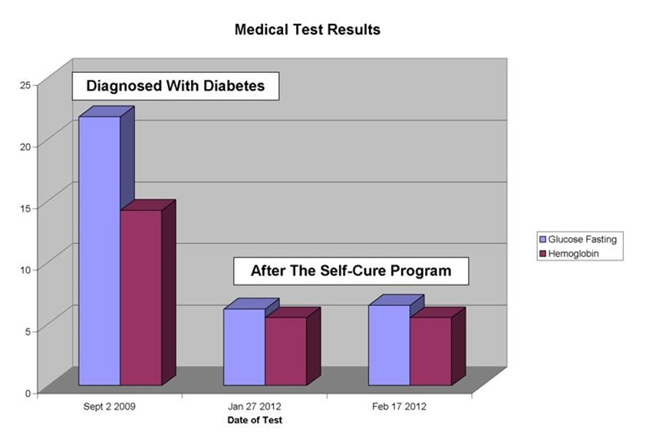](https://express-press-release.net/news/wp-content/uploads/2018/11/medical-test-results.jpg)

———————————————————————————————————————————–

Ernest Quansah is a type 2 diabetes Lifestyle Strategist, diabetes educator, keynote speaker, and the author of ***Diabetics Journey***. He is the founder of Just For Diabetics.

He is available for radio, press, and TV interviews, as well as speaking engagements.

Diabetics Journey **ISBN-13:** 978-0994767035

available at [**Amazon**](https://www.amazon.com/dp/099476703X/ref=cm_sw_su_dp)

Website: <https://justfordiabetics.com/>

Media Kit: <https://justfordiabetics.com/media-kit/>

Email: [ernest@justfordiabetics.com](mailto:ernest@justfordiabetics.com)

====

Press release distributed via EPR Network (<http://express-press-release.net/submit-press-release.php>)