Travel Packages to Kenya and Tours in Nairobi National Parks

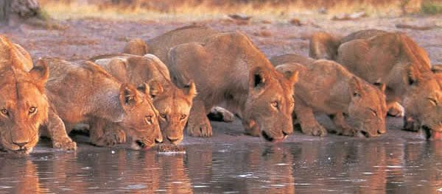
NAIROBI, Kenya, 2018-Nov-16 — /EPR Network/ — Kenya’s National Airliner Kenya Airways launched its direct flights from Nairobi Jomo Kenyatta International Airport on 28th October, 2018 to New York John F. Kennedy Airport. This new route is intended to open up the 2 vibrant economies. Travel from the USA to Kenya will only be 15 hours or there about with no connection hassles, no lay overs and stop overs. Trade and investment, Horticulture, Technology and Tourism are the most key sectors that are likely to benefit from the introduction of this route. According to the transport PS in Kenya, Mr. Macharia on an interview by Jeff Koinange he said ‘it has been a journey of about 10 years to have this dream come true for Kenya. Not only will Kenya benefit but also other feeder airlines both local and from neighbouring countries’.
Cruzeiro Safaris Kenya intends to benefit from this route as by introducing its tourism services to the nationals of North America, Central America and South America. Tourist will be able to fly to Nairobi in the morning and fly to other destinations the same day or drive by road without having to stay overnight in Nairobi. On the last day, tourist can venture into Nairobi City and other attractions around. Kenya Airways office in New York, USA is located in the Broadway or can be booked online through any flight search engine or any travel Agent.
Business travellers can now book Airport transfers and Short tours for 3 hour to 11 hours. Trip planning is important in this era of technology.
Top end Safaris: private lodges, Luxury tented camp and even private fly-in camps are used in top end safaris, all with the aim of providing guests with an ‘authentic’ and personal bush experience as possible without foregoing the comforts. For the price you pay expect a full range of amenities, as well as top-quality guiding. Even in remote settings without running water you will be able to enjoy hot, bush-style showers, comfortable beds and fine dining. Also expect a high level of personalised attention and intimate atmosphere- many places at this level have few than 20 beds.
Mid-range Safaris – Most mid-range safaris use lodges, where you will have a comfortable room and eat in a restaurant. Overall, safaris in this category are reliable and reasonably good value. The prices for staying in lodges or tented camps are considerably higher on the whole.
For most Tourist Safari is summed up in two poetic words as Masai Mara. This is Understandable, after all the Mara has fuelled African fantasies for years and without the shadow of a doubt, its wildebeest-spotted savannahs are the star attraction of what is a star-studded region. The road trip to Masai Mara can take anywhere from 5-7 hours which the flights from Nairobi will take 45 minutes to 1 hour depending to the number of stops.
If one is planning to take a safari with Cruzeiro Safaris Kenya here are some of the options you may have with the key wildlife park Masai Mara visit.
Fly-in Safaris from Nairobi
- Samburu Reserve and Masai Mara – 5 Days
- Masai Mara only – Naibosho conservancy – 5 Days
- Governors Camp Masai Mara – 2 Days
- Masai Mara – Eagle view camp (less than 15 tents) – Plains view location and water hole very private – 3 days
- Masai mara –Serena Masai Mara – 3 Days
- Kichwa Tembo Tented Camp Luxury – and beyond property – 3 Days
- Mara Intrepid Camp – Luxury Glamping ONLY – 3 Days
- Kenya and Zanzibar beach – 9 Days
- Top Notch Luxury Accommodation – 7 Days
Road trips in Kenya from Nairobi
- Mount Kenya and Masai Mara – 9 Days
- Safari twiga – 9 Days
- Safari Ndovu – 6 Days
- Lake Nakuru and Masai Mara – 4 Days
- Africa Safari drop off Mombasa or stat from Mombasa – 9 Days
- Budget travel to Masai mara – 3 Days
About Cruzeiro Safaris Kenya
Cruzeiro-safaris.com is established in Kenya, incorporated in 2004. Its core business is Safari Packages and Day Tours complemented by air travel. It has a well-established wealth of experience in arranging memorable tours and safaris and has established a client base who provide with repeat business year after year. Join us on facebook, twitter and youtube. Safaris in Kenya may be tailored to the tourist taste and can extend to Tanzania and Uganda.
For further information and reservations, Contact;
Claudia Kabui
Mobile Sales : +254722370833 (Kenya)
Operations : + 254710729021 (Kenya)
Email: info@cruzeiro-safaris.com
Website: | https://www.cruzeiro-safaris.com and https://cruzeiro-safaris.com/nairobi-tours/
===
Press release distributed via EPR Network (http://express-press-release.net/submit-press-release.php)

