SOULED OUT NAMED WINNER IN THE KNOT BEST OF WEDDINGS 2018
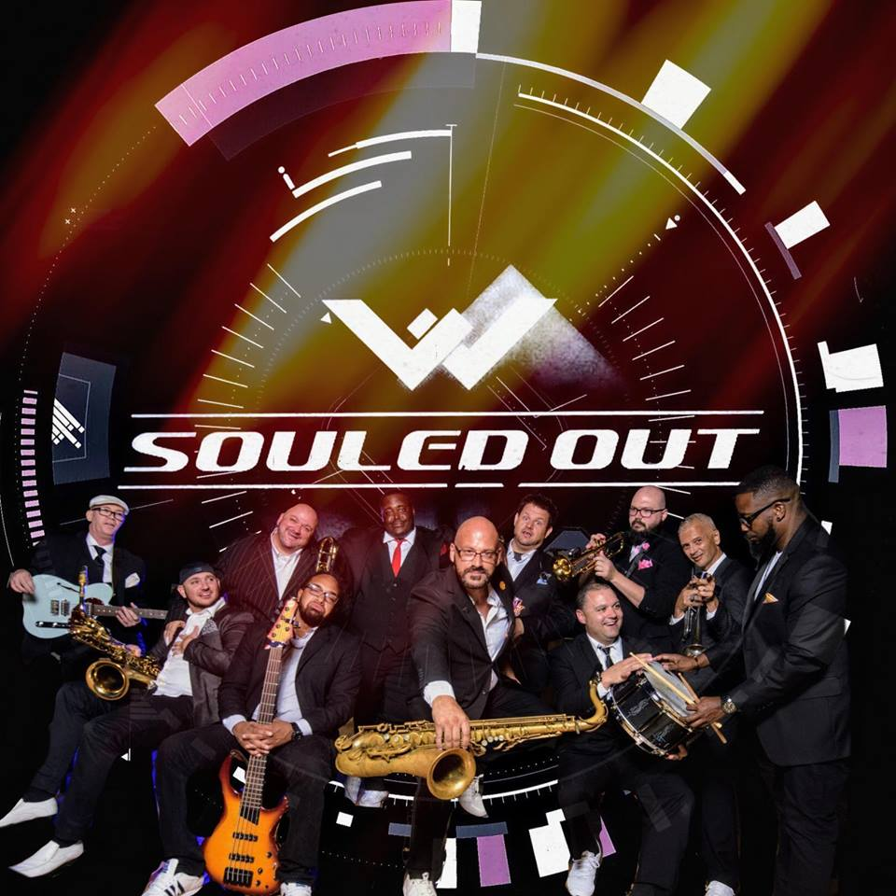

SOULED OUT IS: (L to R) Glenn Zeringue Jr. (Guitar), Ryan Lottinger (Saxophones), Matt “Spanky” Larose (Trombone), Evan Washington (Bass), Jared Price (Vocals), Dave Mouton (Saxophones), Colin McGibboney (Vocals), Blake Guidry (Keyboards, Vocals), AJ Gribble (Trumpet), Scott Pierce (Trumpet), Mac Carter (Drums) Not pictured: Lynell Cyprian (Vocals), Byron Santo (Sound Engineer)
Thirteenth Annual Best of Weddings Awards, from the #1 Wedding Planning Website, Honor the Top Wedding Vendors Across America
Lafayette, LA, 2018-Dec-11 — /EPR Network/ — Souled Out is pleased to announce that they have been selected as a 2019 winner in The Knot Best of Weddings, an award representing the highest-rated wedding professionals as reviewed by real couples, their families and wedding guests on The Knot, the leading online wedding brand and app. This is the first year Souled Out has been selected for The Knot Best of Weddings.
In 2018, only 3% of the approximately 300,000 local wedding professionals listed on TheKnot.com have received this distinguished accolade. In its thirteenth annual year, The Knot continues its longstanding tradition of supporting local wedding vendors with The Knot Best of Weddings 2019, an annual bycouples, for-couples guide to the top wedding professionals across the country. To determine the winners, The Knot assessed almost 3.6 million reviews across the various vendor categories—venues, musicians, florists, photographers, caterers and more. These winners represent the best of the best wedding professionals that a bride or groom would want to consider booking for their own unique wedding.
“We are just humbled to be recognized as one of the top Wedding Bands in the Louisiana area! Souled Out loves celebrating with our happy Couples, and we look forward to what 2019 brings us!” said David Mouton, owner & saxophonist of Souled Out Entertainment LLC. As the number one online wedding brand and app, The Knot has inspired approximately 25 million couples to plan a wedding that’s uniquely theirs. With a rich history of providing quality content and inspiration, The Knot is making it easier for couples to connect with and book just the right wedding professionals to create their perfect wedding day. Eight out of 10 couples come to The Knot where they can be connected to any of the approximately 300,000 local wedding professionals across the country. The Knot marries great technology with trusted content–and a little love–to make planning for the most important day of a person’s life easier and more enjoyable.
For more information about The Knot Best of Weddings and a complete list of winners, please visit https://www.theknot.com/vendors/best-of-weddings
About Souled Out
Souled Out is an eleven piece band hailing from across south Louisiana. Conceived in 2001, Souled Out has been entertaining audiences with its unique brand of interaction and choreography. Souled Out has entertained wedding receptions, corporate events, Mardi Gras krewes and nightclubs in Alabama, Louisiana, Mississippi, Florida, Tennessee and Texas. Souled Out has earned “Best Band” by the Tri-Parish Times on three separate occasions as voted for by their endearing fan base. Souled Out is a four time WeddingWire.com ‘Couples Choice’ Award Winner (2016, 2017, 2018) in addition to being named ‘Top Rated Online’ based on client reviews from various online wedding resources. In 2018, they were named “Best Cover Band” by The Times of Acadiana. As one writer recently pinned, “Souled Out is the band you’ve always wanted to see….but didn’t! When you attend a Souled Out performance, you’re forced to listen with your eyes wide open!”
If you’re looking to have a band that brings energy, great music AND performs in such way that it brings people together then Souled Out might be your band. Despite the fact that they’ve performed at well over a thousand weddings since 2001, Souled Out has developed a niche of being the band that not only entertains your guest but becomes the “life of the party”. Each and every reception performance is a very personal and unique experience for all of their clients. The goal at every event that we are honored to be a part of what is the vision that the client had during their planning process. Many clients that utilize Souled Out’s services didn’t want the “typical” band – they wanted much more and they choose Souled Out. Please visit Souled Out online at www.SouledOutLA.com and follow on social media: https://www.facebook.com/souled.out.54/ and @souledoutla on Twitter and Instagram
About The Knot
The Knot is the nation’s leading online wedding brand and app that seamlessly engages, matches and connects couples with the right products, services and local wedding professionals they need to plan and pull off their wedding. The trusted brand reaches a majority of engaged couples in the US through the #1 wedding website TheKnot.com, its mobile apps, The Knot national and local wedding magazines, and The Knot book series. The Knot has inspired approximately 25 million couples to plan a wedding that’s uniquely them. The Knot is the flagship brand of XO Group Inc. (NYSE: XOXO), which helps people navigate and enjoy life’s biggest moments—from getting married to moving in together and having a baby.
Please visit The Knot online at TheKnot.com and follow on social media: Facebook.com/TheKnot and @TheKnot on Twitter, Pinterest and Instagram.
====
Press release distributed via EPR Network (http://express-press-release.net/submit-press-release.php)

