**Koincable HDMI Cables Now Used for Various Electronics**

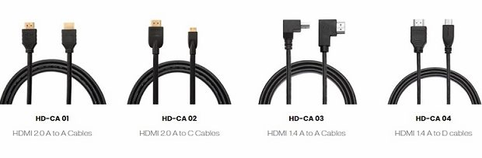

Dongguan City, Guangdong Province, China, 2019-Jan-27 — /EPR Network/ — Koincable has been a manufacturer of high-quality custom HDMI cables for more than thirteen years. Today, their products can now be seen in electronics for different purposes.

They have four types of [HDMI cables](https://www.koincable.com/hdmi-cables-beginners-guide/) that can be modified to fit the preferences of their clients. These are the HD-CA 01 (HDMI 2.0 A to A cables) that supports 18Gb/s transfer speed and 4K resolution making the 3D viewing experience better, HD-CA 02 (HDMI 2.0 A to C cables) that supports 1080p resolution, also ideal for 3D viewing and is compatible with mobile devices, like cell phones, pads, tablets, notebooks, cameras, and more, HD-CA 03 (HDMI 1.4 A to A cables) that supports a 3840×2160 resolution and can be used in gaming devices, such as the PSP and Xbox, and the HD-CA 04 (HDMI 1.4 A to D cables) that also supports 1080p resolutions, 4K source movies, and can be used in cell phones, cameras, pads, tablets, and notebooks among others.

Their cables are also made from premium materials to ensure smooth transmission of data and for the cables to last long. The PVC jacket makes the cables flexible and durable, so they can be bent and folded easily when the devices are set up. They also come with a plastic housing to promote easy grip. However, if clients prefer certain materials, the cables’ materials can be customized as well. Among the materials that clients can choose from are aluminum, silver, copper, tin, and gold.

According to Koincable personnel, “Since HDMI cables are so versatile, our customers have different features they want in their products. We always aim to provide excellent service, which is why we need to keep up with the fast evolving of these cables. We will meet their requirements, but at the same time, give them recommendations to make their cables more effective.”

The Koincable HDMI cables can now be used in the following electronics:

* HD sources, such as AV monitors (digital televisions) and AV receivers, such as DVD players and Blu-ray Discs  
  Set-top boxes that can provide better images when transmitting the source signal into content and view on TV screens.
* Video games, such as the PSP and Xbox, which creates more-detailed images that promote a better viewing experience.
* Display devices, like monitors, computers, LCD TVs, and others

**About Koincable**

Koincable is one of the leading manufacturers of HDMI cables from China. They have been providing high-quality cables and excellent services for more than thirteen years now. Their vast knowledge and experience have allowed them to grow and mature, ensuring clients that all of their cables are made carefully by their skilled engineers and workers.

If you wish to know more about Koincable and the different cables they manufacture, please contact them through the following contact info:

Email: sales@koincable.com  
Telephone No.: 0086-769-22885121  
Fax: 0086-769-22885120  
Website: [www.koincable.com](http://www.koincable.com/)

Logo:

[](https://express-press-release.net/news/wp-content/uploads/2019/01/KOINCABLE.jpg)

**Koincable logo**