BIBI LED Releases Their Latest Indoor Fixed LED Display Screen

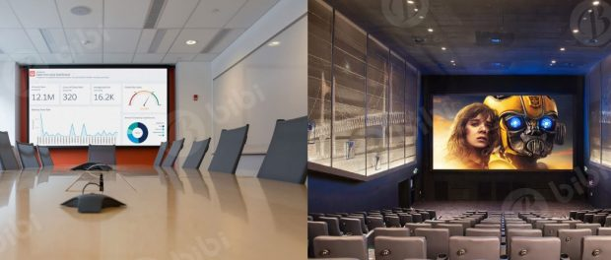
Shenzhen, Guangdong, China, 2019-Mar-02 — /EPR Network/ — BIBI LED has released their latest indoor fixed LED display screen and it is certainly better than its previous versions. It boasts of a weight of only 14kg for each 640x640mm die-casting aluminum cabinet. Its standard module size of 320x160mm and standard cabinet size 640x640mm, have both front and back access. This makes it one of the easier LED screens to install. In fact, you can install a whole cabinet with just two people doing all the necessary work.
Its die-casting aluminum cabinet is made by a CNC machine. This ensures that the gap and flatness are better than normal steel cabinets. It is also a very efficient indoor LED display screen. It has a maximum power consumption of 800 W/m2 and an average of 250 W/m2. That’s how energy efficient it is.
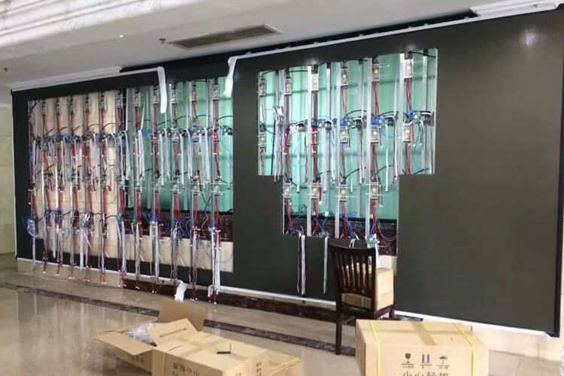
Why Use Indoor Fixed LED Display Screens?
There’s a reason why indoor fixed LED display screens are the more preferred medium for videos and images. Here are some of the reasons.
Brightness – In terms of brightness, the LED screen has enough brightness that you don’t have to worry about ambient light. You will always see clear pictures even if the lights are on.
Size – Size will never be an issue for an LED screen/wall. The size of the display for an LED screen/wall virtually has no limit. You can just combine panels or cabinets to achieve the size that you want.
Cost – Generally, LED screens are more expensive upfront. But over time, you will be able to save more mainly because they consume less electricity than other mediums. Plus, maintenance costs are next to zero when you use LED screens. So, using indoor fixed LED screens are the better long term investment.
Performance – When we’re talking about performance, an indoor LED screen will definitely outperform any display device. In terms of clarity and sharpness of images and videos, LED screens are on the top of the hill. Plus, they are always bright enough that you don’t need to dim the lights in order to see better what is being played.
Know more about what indoor fixed LED screens in this guide: The Ultimate Guide About Indoor LED screen.
About Bibi LED
Located in Shiyan Town, Bao’an district, Shenzhen, China, BIBI LED is one of the leaders in LED screen products and solutions provider. They are dedicated to providing high-quality products and professional services. They only cater to overseas clients.
Providing quality products and services to their clients is their standard of operation. They achieve this by offering excellent pre-sales services. This is their way of making sure that every client will have what they need. Plus, they also offer excellent post-sales services like providing all-around solutions for their client’s projects. They also offer technical training to those who don’t have any experience handling products that they sell.
The level of commitment they have ensures that the satisfaction of their clients is their priority. By partnering with them, you will be guaranteed that your needs will be met and your business will go a long way.
Contact-Details:
Office number: +86 755-85288654
Whatsapp: +86 15399906913​
Email: info@bibiled.com
https://www.bibiled.com/
===
Press release distributed via EPR Network (http://express-press-release.net/submit-press-release.php)

