Moxy OID Has Created CERLOS, A New, Non-Toxic, Eco-Friendly, Lower Cost and More Durable Construction Material Developed From Agricultural and Forestry Waste Products

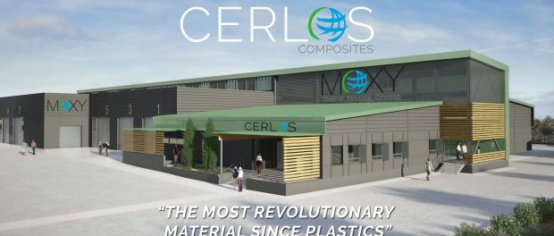
“CERLOS Is The Most Revolutionary Material Since Plastics”
Vancouver, B.C., Canada, 2019-Mar-06 — /EPR Network/ — Moxy OID introduces CERLOS to the world after 20 years of research and development plus more than $20 million in production and testing. CERLOS is a new building material with superior properties compared to existing wood, fiber cement, plastics and other building materials.
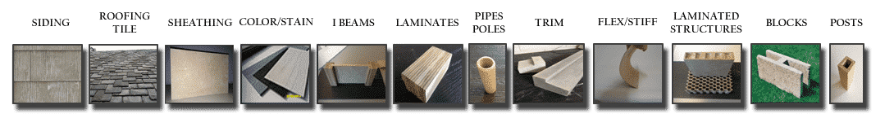
CERLOS Benefits Include:
- CERLOS is Class A Fire Rated.
- CERLOS is mold and mildew resistant.
- CERLOS termite, insect, rodent and bird resistant.
- CERLOS is water stable, will not shrink or swell.
- CERLOS does not produce toxic dust for installers or home owners.
- CERLOS installs like wood with standard carpentry tools.
- CERLOS is non-toxic from production through disposal.
- CERLOS does not crack or chip easily, eliminating installation issues.
- CERLOS is more durable than competitive building materials.
CERLOS Is The Low Cost / Higher Quality Choice for Building Contractors and Consumers
Most importantly, CERLOS will typically sell for less than virtually all competitive building products while offering a superior installation and homeowner experience.
With Moxy OID first to market product CERLOS Siding, home builders, building contractors, installers, and home renovators will enjoy spending less for installing a long lasting, stable, nearly maintenance-free CERLOS Siding compared to fiber cement, wood, vinyl or aluminum options.
Consumers benefit by requesting CERLOS because of the superior properties at the same or lower cost of competitive products. Issues with mold, fire resistance, toxic dust during installation, cracking, swelling, ecological impact, and cost go away when consumers choose CERLOS for their homes.
According the Robert Bedard, CEO of Moxy OID:
“We feel it is important to enter the marketplace first with CERLOS Siding, then CERLOS Roofing so we can bring you a fire resistant, water stable, bug, rodent and bird resistant envelope to your home saving you saving time, money and ultimately your life.”
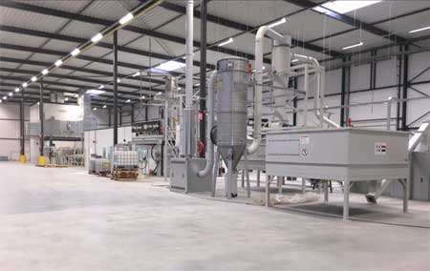
CERLOS Is Ready for Moving to Full Scale Production
A pilot plant was constructed to test the complex and proprietary process for creating CERLOS. The pilot plant, validated production of CERLOS material as designed, ensuring that the unique process can be scaled to reach production quantities for world-wide commercialization.
Since proving the CERLOS proprietary process will scale to commercial levels, Moxy OID has now moved towards funding the first, commercial scale plant for producing siding products.
How To Get Involved With Moxy OID and CERLOS
Building contractors, home builders, architects, renovators and home owners can learn more and become part of this exciting, eco-friendly building material revolution by visiting signing up for updates at MoxyOID.
About Moxy OID
Founded by Robert Bedard and Alan Heywood in British Columbia, Canada, Moxy OID has been developing CERLOS since about 1998. Now that CERLOS is ready for the commercial market, Moxy OID has shifted from R & D to marketing, funding, plant development, and offering territories for CERLOS distribution to building supply and contractor businesses. Learn more at Moxy OID.
Contact:
Robert Bedard
rbedard@moxyoid.com
888-809-8859
===

Press release distributed via EPR Network (http://express-press-release.net/submit-press-release.php)

