Best Top Travel Packages, Tours and Safaris in Nairobi, Kenya – Visit the Nairobi National Park
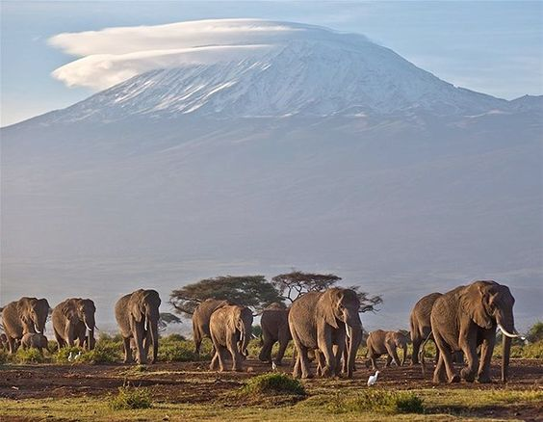
Nairobi, Kenya, 2019-Mar-11 — /EPR Network/ — The Conference season is here and all delegates are Welcome conducting their conference meetings and workshops in Nairobi the capital city of Kenya.
Simple words to learn:
Jambo – Hallo
Habari Yako – How are you?
(Sasa? – Hi? Reply: Poa – am fine ) slang language on sheng
Asante – Thank You
Asante Sana – Thank you very much
Naomba funguo ya chumba XXXXX – May I have the key to room xxxxx
Naomba maji ya kunyua? – May I have some water to drink ?
Ni nataka taxi ya kwenda xxxx – I want a taxi to go to xxxxx
Hii ni pesa ngapi? – How much is this?
Want more ask your driver while on a tour in Nairobi through Cruzeiro Safaris Kenya. Book any tour online on https://cruzeiro-safaris.com/nairobi-tours/
Or click any links below:
Tours
1. Nairobi National Park Tour Morning
2. Nairobi National Park Tour Afternoon
3. Nairobi National Park Tour and Elephant Orphanage
4. Nairobi National park Tour, Elephants and Giraffe
5. Nairobi National Park Tour, Elephants, Giraffe and Lunch
6. Elephant orphanage, Giraffe Centre and Karen Blixen Museum
7. Elephant orphanage and Giraffe centre
8. Giraffe Centre and Karen Blixen Museum
9. Elephant orphanage only
10. Nairobi Safari Cat show and Dinner
11. Cultural Tour Afternoon -Bomas of Kenya
12. Lake Naivasha and Crescent Island Walk Full Day Trip
13. Lake Nakuru National Park Full Day Trip
14. Amboseli National Park Full Day Trip
Safaris From Nairobi
1. Top Choice to Africa Safari for 5 days by air only
2. Samburu and Masai Mara for 5 days by air only
3. Masai Mara to eagle view Private Camp for 3 days by air only
4. Mara Serena Safari 3 days by air only
5. Governors Camp 2 Days Safari by air
6. Amboseli Park 2 Days Safari by road
7. Amboseli Park 3 Days Safari by road
8. 4 Days Safari to Lake Nakuru and Masai Mara by road
9. 6 Days Safari to Amboseli , Lake Nakuru and Masai Mara by road
10. 9 Days Safari from Nairobi to Mombasa or vice versa by road
11. 9 Days Mount Kenya and Masai Mara by air and road
12. 3 days luxury travel Package Mara Intrepids by air
13. 9 Days Safari Twiga by road and air
Culture: Kenya’s greatest asset, aside from animals, is its people, consisting of over 42 trips. The Maasai are the most well-know and still practice their traditional way of life, wearing the red robes and beaded jewellery for which they are famous. Not as war like as they once were, they still raise cattle and live by the land. Tribal life isn’t the only influence on Kenyan Society- colonial history is still evident and at the coast in particular culture is predominant.
Activities on Land, on the water and in the air, Kenya has enough activities to keep the most experienced adrenaline junkie happy and some will demand more energy than others. The Marathons, Mountain trekking, golfing, hot air balloon and Carmel derby trekking.
About Cruzeiro Safaris Kenya
Cruzeiro-safaris.com is established in Kenya, incorporated in 2004. Its core business is safari packages and day tours complemented by air travel. It has a well established wealth of experience in arranging memorable tours and safaris and has established a client base who provide with repeat business year after year. Join us on facebook, twitter and youtube. Safaris in Kenya may be tailored to the tourist taste and can extend to Tanzania and Uganda.
For further information and reservations, Contact;
Claudia Kabui
Mobile : +254-(0) 722-370833 (Kenya)
Sales: + 254 (0) 710-729021 (Kenya)
Email: info@cruzeiro-safaris.com
Website: | https://www.cruzeiro-safaris.com and https://cruzeiro-safaris.com/nairobi-tours/

Press release distributed via EPR Network (http://express-press-release.net/submit-press-release.php)

