**New Services Larry Hurt income Tax Services**

[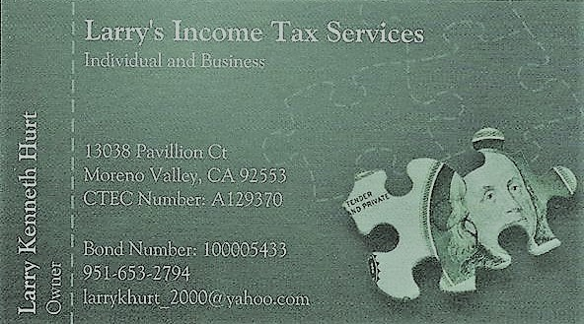](https://express-press-release.net/news/wp-content/uploads/2019/03/LARRY-K-HURT.jpg)

Moreno Valley, CA, USA, 2019-Mar-12 — /EPR Network/ — Over 49 years preparing taxes for individuals and small businesses, able to assist individuals in the cryptocurrency business with their tax preparation(s), 16 years as a Notary and 8 years as a Signing Agent.

Experienced Owner with a demonstrated history of working in the consumer services industry. Skilled in Nonprofit Organizations, Budgeting, Business Planning, Microsoft Word, and Coaching. Strong entrepreneurship professional with a Master Degree focused in Human Resources Management/Personnel Administration, General from Golden Gate University.

I also severed 23 years in the US Air Force. For 22 years as an additional duty, I severed as the Unit Non-Commission Officer Tax Representative. My job was to assist military and civilian personnel assigned to the Base, helping or completing their Tax returns and answer tax questions. During tax season, I spent 4 hours on Saturday at the Base Legal Office assisting people with their tax returns. After retiring in 1991, I continued doing taxes and opened my own business.

My tax specialties are Individuals, Small Businesses, S Corporations, Nonprofit Organizations, Tax Planning, Uber, Lyft and CryptoCurrency. Thank you.

To learn more go to https://larrykhurtincometaxservices.nicbuilder

**Contact-Details:**  
Larry K Hurt  
13038 Pavillion Ct.  
Moreno Valley, CA  
Home Phone 951-653-2794  
Fax 951-653-2794  
larrykhurt_200@yaho.com  
https://larrykhurtincometaxservices.nicbuilder

===

Press release distributed via EPR Network (<http://express-press-release.net/submit-press-release.php>)