7 Belt Storage Tips

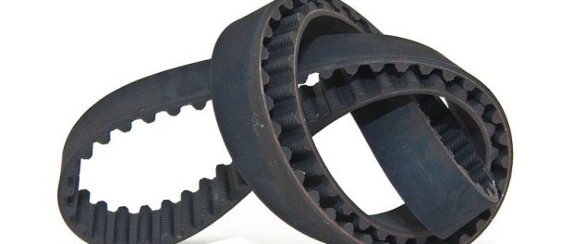
Perth, WA, Australia, 2019-Mar-15 — /EPR Network/ — Even though most technicians know that the way that belts are stored can have a significant impact on their performance, the appropriate level of attention and care isn’t always paid to belt storage.
Often, improper storage procedures are the reason for premature belt failure. Improper storage can damage the tensile cord, dooming the product to failure because of damage incurred prior to installation on the drive.
For belts to retain their serviceability and for optimum reliability and consistent performance, they have to be properly stored. It’s as simple as that.
Proper storage means:
- Less likelihood of premature failure
- Extended service life
- Improved performance
- Enhanced safety
- Better warranty protection
Here are seven recommendations for proper belt storage:
1. Store belts in a cool and dry environment. Ensure belts are stored away from windows or glassed areas, so as to avoid direct sunlight and eliminate any risk of exposure to moisture.
2. Belt performance is halved for every 9.50C above 460C, so if your operation is located in areas where extreme heat is experienced, such as many sites around Western Australia, you need to take extra precautions to maintain moderate temperatures where the belts are stored. The temperature should not exceed 29.50C and relative humidity should be below 75% to prevent the risk of mildew or fungus.
3. Belts should also be stored well away from any heating device or ozone-generating devices such as transformers and electric motors. They should also be kept well away from any risk of contamination from airborne chemicals.
4. Store belts on shelves in boxes (preferably the original box) or other protective containers, but don’t force the belts into the boxes and distort them. Avoid crimping or sharp bends in the belts too. You should also limit the contents of each container to prevent the weight from damaging the belts at the bottom of the pile.
If you can avoid it, keep belts off the floor as they risk getting damaged from traffic as well as from liquid or chemical spills.
5. When storage time exceeds six months, the belt tension should be relaxed. If stored properly under the right conditions, belts can be stored for up to six years.
6. Avoid twisting, bending or crimping belts during handling and storage as this may damage them. Always adhere to the manufacturers’ recommendations in terms of bending diameter and tension. Longer belts can be stored coiled in large diameter loops.
7. Avoid hanging belts from small diameter pegs as they could distort over time caused by the suspended weight of the belt, but if you are storing the V-belt on a wall rack, use a saddle that has a diameter at least as large as the recommended sheave or sprocket minimum for that particular cross-section.
By adhering to the guidelines and recommendations above, you will gain the maximum life and optimum reliability and performance from your V-belt or synchronous belt.
For any other information about belt storage and handling procedures, or for any other technical equipment query, get in touch with the professionals at Nexxis.
Nexxis is a leading Australian supplier of world-class technical equipment for a wide cross-section of industries and their experienced team will be more than happy to answer any questions you may have. Get in touch with them on 08 9418 4952 or visit nexxis.com.au.
Contact-Details: Nexxis
12/55 Erceg Road
Yangebup WA 6164
Australia
+61-8 9418 4952
https://nexxis.com.au/
admin@nexxis.com.au
Logo:
Nexxis logo

Press release distributed via EPR Network (http://express-press-release.net/submit-press-release.php)

