Travel and Tour Packges Online Booking Site for Nairobi Kenya

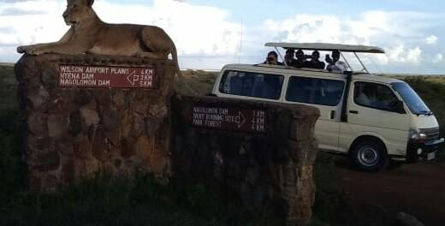
NAIROBI, Kenya, 2019-Jun-28 — /EPR Network/ — Kenya’s tourism industry is booming in business and 2018-2022 is looking even better after recovery for a long time. Cruzeiro Safaris Kenya’s strength in packaging tours and committed service delivery is expected to increase in the future.
Undoubtly, Kenya is the best African country for safari experience with lots and lots of wildlife viewing. For a long time Cruzeiro Safaris Kenya, has taken travelers to various destinations within Nairobi and tourist destinations within Kenya, Tanzania and Zanzibar.
The Tour Operator has for years utilized the distributions of International brands to marketer and distribute their tours on commission basis. The distributors had a competitive advantage in that the clients could read and book tours online to the last stage. They will still continue distributing through their online partners.
Cruzeiro Safaris Kenya saw this as an opportunity to exploit and dive into the big ocean of international brands. This challenge has been overcome and now this Online Tour Agency (OTA) and operator have launched their online tours booking platform in collaboration with payment getaway PESAPAL which is verified by VeriSign International. PESAPAL accept credit cards VISA and MASTERCARD and mobile money as well.
‘Delving into the online market is worth the risk, because Nairobi is become the hub for multi-national corporations, we believe we shall make significant strides in terms of sales revenue. Our service delivery remains top-notch and continuous priority as you can read from the trip advisor page and other pages. Just Google Cruzeiro Safaris Kenya’ says Susan the Tourism Manager.
Some of the tours they offer in for a start on their online tours platform in Nairobi are:
- Nairobi National Park Morning
- Nairobi National Park Afternoon
- Elephant Orphanage Tour
- Elephants Orphanage And Giraffe Center
- Nairobi National Park Tour And Elephants Orphanage
- Nairobi National Park Tour, Elephants Orphanage And Lunch
- Nairobi National Park Tour, Elephants Orphanage And Giraffe Center
- Nairobi National Park Tour, Elephants Orphanage, Giraffe Center And Lunch
- Full Day Tour To Lake Nakuru National Park
- Full-Day Safari Tour To Amboseli National Park From Nairobi

Some of the overnight safaris they offer are only related to Luxury travel lodges and one fly’s by Air (Safaris by Air). The destinations includes:
- Masai Mara Safari Low Season Offer
- Masai Mara Safari to Governors Camp
- Masai Mara Safari to Eagle View Luxury Camp
- Keekorok Lodge
- Airport Transfers from Airport to Nairobi Hotels
- Airport Transfers from Airport to Other Hotels listed
- Full-Day Stone Town And Prison Island Tour In Zanzibar – Central Hotels And Fumba
- Full-Day Stone Town And Prison Island Tour In Zanzibar
- Full-Day Stone Town And Prison Island Tour In Zanzibar- Stone Town Hotels
- Spice Tour Of Zanzibar – South Hotels
- Spice Tour Of Zanzibar – North East And Central
- Spice Tour Of Zanzibar – Stone Town Hotels
- Spice Tour Of Zanzibar – North Hotels
- Zanzibar Arrival Transfer: Zanzibar Airport To Hotel
However, there are more packages available in their main website with several detailed tailor made safaris by road ranging from 1 (one) day to 15 (fifteen days) safaris. www.cruzeiro-safaris.com
We wish you happy holidays, great experiences in Kenya and book through Cruzeiro Safaris Kenya.
About Cruzeiro Safaris Kenya
Cruzeiro-safaris.com is established in Kenya, incorporated in 2004. Its core business is safari packages and day tours complemented by air travel. It has a well established wealth of experience in arranging memorable tours and safaris and has established a client base who provide with repeat business year after year. Join us on facebook, twitter and youtube. Safaris in Kenya may be tailored to the tourist taste and can extend to Tanzania and Uganda.
For further information and reservations, Contact;
Claudia Kabui
Email: info@cruzeiro-safaris.com
Website: | https://www.cruzeiro-safaris.com and https://cruzeiro-safaris.com/nairobi-tours/
Mobile : +254-(0) 722-370833 (Kenya)
Sales: + 254 (0) 710-729021 (Kenya)

Press release distributed via EPR Network (http://express-press-release.net/submit-press-release.php)

