The Bell Tower Receives its Third TripAdvisor Certificate of Excellence

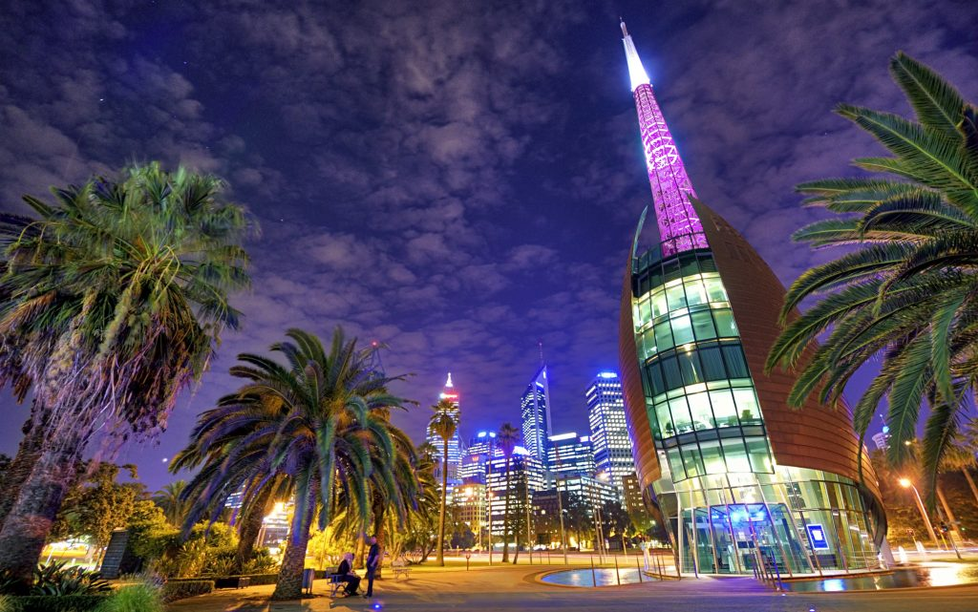
The Bell Tower Receives its Third TripAdvisor Certificate of Excellence
PERTH, Western Australia, 2019-Jul-16 — /EPR Network/ — The Bell Tower has done it again! We are so excited to announce that for the third consecutive year The Bell Tower has received a TripAdvisor Certificate of Excellence. These certificates are awarded from TripAdvisor to businesses with consistent excellent reviews on their site.
What Are Visitors Saying About the Bell Tower
“Love locks that you can order and engrave with a special loving message and lock it forever to the rails out the front. Very special and romantic.” – Beck
“An incredible piece of artwork in itself. The bells will go off on the hour and it’s lovely just to sit on the Quay and listen without even going in.” – Morzor
“Loved chiming the bells, hearing the deep ANZAC bell, cheerful commentary by Marion, fantastic views of Perth and artifacts and info to browse.” – LEBonham
“What an incredible structure and so perfectly presented. A very friendly guide was there to explain all the details and the history of the tower and some of the bells. It is worth a visit just for the views which are quite wonderful over the Swan River” – JPPetty
“We loved the Bell Tower – its shape, the sound of the old bells from London and how it looks at night when it is lit up. A ‘must do’ attraction.” – Margaret
What is the “TripAdvisor Certificate of Excellence”?
TripAdvisor have been awarding the Certificate of Excellence to hospitality businesses that deliver consistently great service across the world since 2011. This achievement is earned over time – there is no application process for the Certificate of Excellence.
To qualify for the Certificate of Excellence, a hospitality business must:
• Maintain an overall TripAdvisor rating of at least four out of five
• Have a minimum number of reviews
• Have been listed on TripAdvisors for at least 12 months
(https://www.tripadvisor.com/TripAdvisorInsights/w604)
We would love to welcome you to The Bell Tower to see what our visitors are enjoying about our very special venue right here in Perth.
Contact-Details:
Gerry Lyng
Barrack Square
Riverside Drive, Perth, WA 6000
https://www.thebelltower.com.au/
08 6210 0444
info@thebelltower.com.au

Press release distributed via EPR Network (http://express-press-release.net/submit-press-release.php)

