Personally Delivered, Inc., Introduces a New Line of Daytime and Overnight Adult Incontinence Pull-On Protective Underwear with Exceptional Absorbency and Comfort

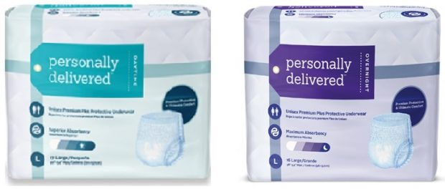
Lake Mary, Florida, United States, 2019-Aug-12 — /EPR Network/ — Personally Delivered, Inc., a leading expert in-home delivery of incontinence, skin care, ostomy, urological, and related supplies, is launching its new, competitively-superior line of Personally Delivered™ Premium-Plus Pull-On Protective Underwear in both Daytime and Overnight styles.
Leveraging 40+ years of listening to incontinence customers and helping them find the right products for their unique situations, Personally Delivered has incorporated the most advanced technologies to create a new unisex pull-on Protective Underwear available in both Daytime and Overnight styles. These state-of-the-art products offer superior absorbency and comfort to help users remain more comfortable, confident, and in control. Customers can now have industry-leading, superior products discreetly delivered right to their front door.
Made in the USA, Personally Delivered™ Pull-On Protective Underwear incorporates gentle cloth-feel stretch panels for maximum comfort and easy removal. A dual-core system plus super-absorbent polymers provide rapid absorbency and superior leak protection. A gel core locks in odors, prevents leaks, and keeps the wearer drier. Comfortable leg gathers deliver active protection and a secure fit. Combined, these features provide the new standard in incontinence comfort and absorbency.
“We speak with people every day who struggle with incontinence and provide real-life feedback on what works and what doesn’t when it comes to leak-free protection,” said Seth Segel, CEO of ConvaTec’s US Home Distribution Group, the parent company of Personally Delivered, Inc. “We understand what these individuals are going through. We listened to them and then went to work creating products to address their problems. Our new Personally Delivered™ Protective Underwear delivers optimal dryness and a leak-free experience.”
Personally Delivered™ Overnight and Daytime Protective Underwear are available exclusively through www.PersonallyDelivered.com. They are available in a range of sizes from Small to Extra-Extra Large.
About Personally Delivered:
Personally Delivered, Inc., a Florida-based member of the ConvaTec family of companies, is a direct-to-consumer supplier specializing in discreet front-door delivery of adult incontinence, skin care, ostomy, urological, and other related products.
Contact-Details:
Shelley Stepp
Marketing Specialist
800-777-1111 ext. 2433
michellestepp@PersonallyDelivered.com
Logo:
Personally Delivered logo

Press release distributed via EPR Network (http://express-press-release.net/submit-press-release.php)

