Tarps Now Expands Offerings of Flame Retardant Grade Welding Curtains, Welding Screens

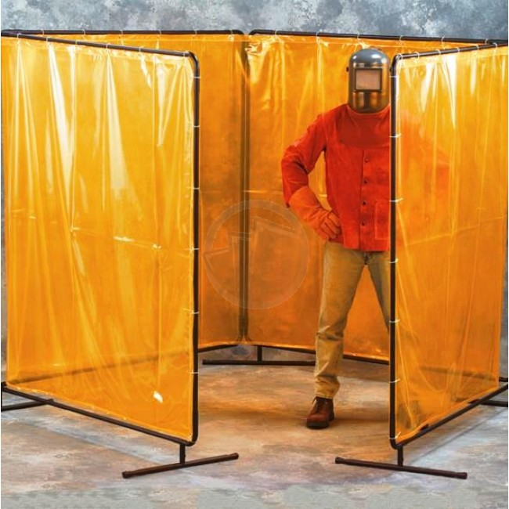
Tarps Now Expands Offerings of Flame Retardant Grade Welding Curtains, Welding Screens
St. Joseph, Michigan, United States, 2019-Aug-12 — /EPR Network/ — Tarps Now® is pleased to announce the expansion of its proprietary lines of flame resistant Welding Curtains, Welding Blankets and Fire-Retardant Tarps that are engineered to improve the workplace safety where welding and industrial heat process takes place and pose an ongoing risk to worker safety.
The new lines of Industrial Grade Welding Screens, Welding Curtains and Welding Blankets now offered by Tarps Now® are engineered to significantly reduce the hazards associated with welding and related industrial processes involving sparks, UV flashes, spatter, and heated dust from manufacturing processes.
In addition to these new lines of welding fabrics, Tarps Now® also announced the release of a wide variety of PVC welding curtains that includes fire resistant, transparent vinyl. While light duty welding blankets typically used for general welding provide protection against light sparks and spatter, these can also be used vertically.
For applications requiring customization, Tarps Now® is the leader in the production of custom Flame Retardant and Fire-Resistant fabrics and related heat resistant fabric materials.
Tarps Now® Flame Resistant Welding Screens, Curtains and Blankets:
https://www.tarpsnow.com/custom-welding-curtains.html
https://www.tarpsnow.com/14-mil-tinted-weld-screen-vinyl-roll-74-5-high-x-89-yard.html
https://www.tarpsnow.com/14-mil-tinted-weld-screen-vinyl-64-high-roll.html
https://www.tarpsnow.com/14-mil-tinted-weld-screen-vinyl-roll-66-high-x-101-yard.html
https://www.tarpsnow.com/freestanding-portable-welding-screen-caster.html
https://www.tarpsnow.com/single-panel-freestanding-portable-welding-screens.html
https://www.tarpsnow.com/two-panel-freestanding-portable-welding-screens.html
https://www.tarpsnow.com/three-panel-freestanding-portable-welding-screens.html
https://www.tarpsnow.com/four-panel-freestanding-portable-welding-screens.html
https://www.tarpsnow.com/welding-curtain-13-oz-flame-retardant-vinyl-panels.html
https://www.tarpsnow.com/welding-curtain-14-mil-transparent-vinyl.html
https://www.tarpsnow.com/welding-curtain-18-oz-flame-retardant-canvas-panels.html
https://www.tarpsnow.com/heat-treated-fiberglass-welding-blankets-18oz.html
https://www.tarpsnow.com/silica-fabric-welding-blankets.html
https://www.tarpsnow.com/acrylic-coated-fiberglass-welding-blankets.html
https://www.tarpsnow.com/gold-slag-fiberglass-welding-blankets.html
https://www.tarpsnow.com/heat-treated-fiberglass-welding-blankets-35oz.html
https://www.tarpsnow.com/silicone-fiberglass-welding-blankets.html
https://www.tarpsnow.com/vermiculite-fiberglass-welding-blankets.html
https://www.tarpsnow.com/black-slag-fiberglass-welding-blankets.html
https://www.tarpsnow.com/aluminum-laminated-fiberglass-welding-blankets.html
https://www.tarpsnow.com/welding-blankets-curtains-screens.html
About Tarps Now®
Tarps Now® features an extensive online catalog of canvas tarps, poly tarps, custom tarps, vinyl tarps and industrial divider curtains. As specialists in custom canvas and vinyl tarps, they are the low-price leaders in their category. The company offers the convenience of fast, easy, online ordering as well as a knowledgeable staff to guide customers through the specification process insuring their project will be completed on time and in budget. Tarps Now® has the experience and scale to insure customer specifications are carefully followed and expectations exceeded for every project, large or small.
Media contact:
Tarps Now, Inc.
4133 M-139
St Joseph, MI 49085
888-800-1383
sales@tarpsnow.com
https://www.tarpsnow.com

Press release distributed via EPR Network (http://express-press-release.net/submit-press-release.php)

