Getting The Most Cash At The Scrap Yard

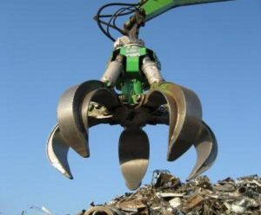
Houston, TX, USA, 2019-Aug-16 — /EPR Network/ — You are probably looking for a scrap yard nearby and got to this page, please click the below link if you searched for a scrap yard near me and need a nearby recycling company. Local scrap yards
Scrap Yards Nearby
Scrap yards are local metal recycling centers, they purchase metals including iron, stainless steel, brass, copper, aluminum & lead.
They will also buy electronics, appliances or cars to dismantle them and sell the steel mill or larger scrap brokers. If you would like to learn how metal is recycled view our article How scrap metal is recycled to learn more.
The metal that scrap yards generate will get melted and reused, that being the case they are a must for our environment.
Here are some tips that will help you to get the most cash from your metal when recycling:
1. Research.
Knowledge is power, and this is the case even at the scrap yard.
Whatever kind of metal you are going to sell will need to be graded by the scrap yard.
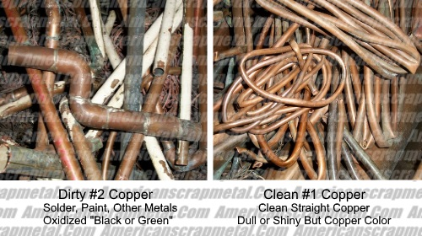
As an example, insulated copper wire or any other copper will be (#1 or #2) depending on a combination of the gauge of copper, insulation type, copper coatings including tin, silver & shellac.
If you have scraps such as plate, sheet or any other for it will depend on if the copper is painted or has other metals attached to it.
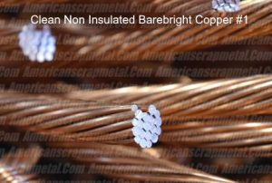
#1 copper that has no insulation or coating will always be worth more than #2 copper, that’s why you need to know what you have before you call or go to the scrap yard.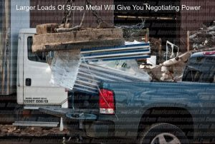
2. More is better.
Bringing larger amounts of weight to the scrap yard will give you more negotiating power.
So figure you have a huge amount of aluminum, the scrap yard is going to really want your business more than they would from someone bringing in a small pickup load.
Local recycling centers make their profit by the ton working on anywhere from $50 to $400 depending on how much they have to invest in the metal.
By gathering a large amount of weight you may be able to get $100 more on a ton of your scrap then if it was 500 lbs. and 4 trips to the yard not to mention you save on fuel, also keep in mind that when at a yard there is a 50/50 chance of getting a flat so unless you have $500-$600 or more worth of scrap metal it’s just not worth it.
3. Separate Your Scrap Metal.
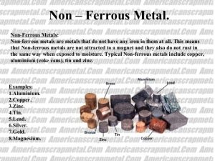
Prior to going to the scrap yard, separate all your metal.
By doing this you will get better scrap metal prices which is an important key to getting the most money for your scrap.
Some pointers:
- Use a magnet to separate magnetic metal (ferrous) which is worth less than non-magnetic metal non-ferrous metals click to learn more.
- Sort your ferrous metal into a tin/steel pile.
- Sort your non-ferrous metal into into other piles such as copper, brass and aluminum.
- Also sort any metal by cleanliness. Example: Clean aluminum blocks will be worth more than a aluminum cylinder head which will have a metal valve cover, steel valves, springs and steel studs.
Media contact:
Americanscrapmetal.Com
David Tene
6324 Alder Dr
Houston, TX 77081
info@americanscrapmetal.com
https://www.americanscrapmetal.com

Press release distributed via EPR Network (http://express-press-release.net/submit-press-release.php)

