Tarps Now® Continues Expansion Supporting the EPC Construction Industry

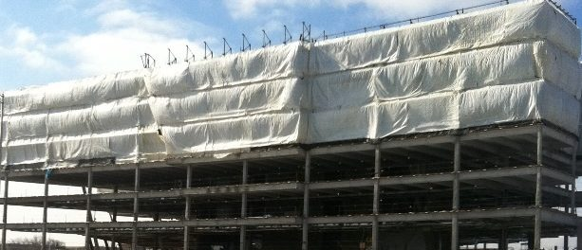
St. Joseph, Michigan, United States, 2019-Aug-16 — /EPR Network/ — Tarps Now® is pleased to announce it has increased commitment to expanding the number of lines of Heavy Duty Tarps and Coverings engineered to meet the needs of Engineering, Procurement and Construction (“EPC”) contractors throughout the North American construction marketplace.
EPC Contractors are firms actively engaged in completing turn-key projects requiring accurate cost quotes, rapid order processing and order deliveries of tarp and covering products used to develop and construct a wide range of facilities.
Projects typically involve large scale construction projects, heavy industry, electric and gas utilities, oil and gas pipelines, retail shopping centers, multi-family community projects, and healthcare industry facility projects.
Tarps Now® EPC Industry Product Highlights:
https://www.tarpsnow.com/construction-tarps.html
https://www.tarpsnow.com/concrete-curing-blankets.html
https://www.tarpsnow.com/debris-scaffold-debris-netting.html
https://www.tarpsnow.com/containment-sandblasting-mesh-barrier-fr.html
https://www.tarpsnow.com/debris-lifting-tarp-snow-tarps.html
https://www.tarpsnow.com/drain-tarps-leak-diverters.html
https://www.tarpsnow.com/geotextile-mesh-screens.html
https://www.tarpsnow.com/airbag-tarps.html
https://www.tarpsnow.com/salvage-covers-and-tarps.html
https://www.tarpsnow.com/painters-drop-cloths.html
https://www.tarpsnow.com/heavy-duty-tarps.html
https://www.tarpsnow.com/heavy-duty-vinyl-tarps.html
https://www.tarpsnow.com/waterproof-canvas-tarps-breathable-tarps.html
https://www.tarpsnow.com/heavy-duty-poly-tarps.html
https://www.tarpsnow.com/heavy-duty-vinyl-mesh-tarps.html
https://www.tarpsnow.com/hypalon-tarps-csm-tarps.html
https://www.tarpsnow.com/neoprene-coated-nylon-tarps.html
https://www.tarpsnow.com/industrial-tarps.html
https://www.tarpsnow.com/industrial-covers.html
https://www.tarpsnow.com/canvas-tarps.html
https://www.tarpsnow.com/custom-fence-screen.html

About Tarps Now®
Tarps Now® features an extensive online catalog EPC Construction products that includes heavy duty tarps, canvas tarps, poly tarps, custom tarps, mesh tarps, vinyl tarps and industrial divider curtains. As specialists in custom canvas and vinyl tarps, they are the low-price leaders in their category. The company offers the convenience of fast, easy, online ordering as well as a knowledgeable staff to guide customers through the specification process insuring their project will be completed on time and in budget. Tarps Now® has the experience and scale to insure customer specifications are carefully followed and expectations exceeded for every project, large or small.
Contact-Details:
Michael Dill, CEO
Tarps Now, Inc.
4133 M-139
St Joseph, MI 49085
888-800-1383
sales@tarpsnow.com
https://www.tarpsnow.com
Logo:
Tarps Now logo
Press release distributed via EPR Network (http://express-press-release.net/submit-press-release.php)

