MS. WEST COAST 2019 CROWNED!

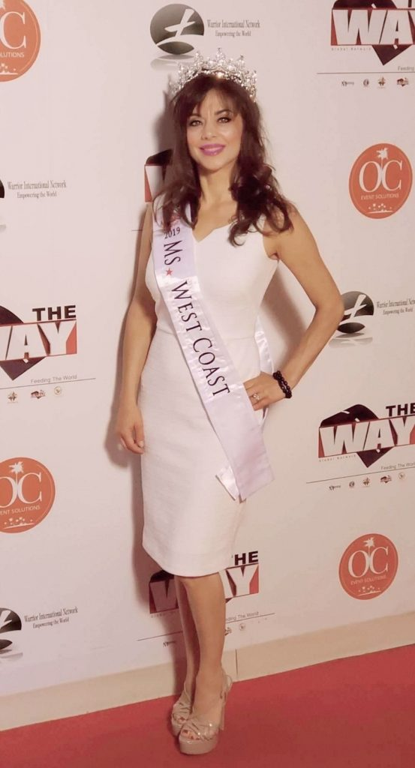
Laguna Beach, CA, USA, 2019-Aug-17 — /EPR Network/ — Joanna Hairabedian of Laguna Beach, CA, has recently been awarded the Ms. West Coast 2019 title by the Ms. America® Pageant.
The Mission of the pageant is to celebrate the accomplishments of women, encourage them to be involved in community service, as well as use the “Crown for a Purpose” to make a difference.
The pageant is open to women 26 years of age and up who are single, divorced or married. The selection process for receiving a title was done by submitting an application, photo and followed up by an interview over the phone. Finalists from across the United States will compete in Interview, Sportswear, Evening Gown and On-Stage Interview and 4 national titles will be awarded at this year’s pageant including Ms. America®, Ms. America® International, Ms. America® Elite and Ms. International™. “Joanna Hairabedian really left a positive impression on our judges and we are thrilled to have her representing California at the 2019 Ms. America Pageant finals this August,” said Susan Jeske, Pageant CEO.
A successful career with NASA endorsed technology increasing blood flow, co-owner of (the zorb.com) providing EMF protection products; Joanna helps others with their mental, physical and spiritual journey. As a singer, songwriter and author, she loves inspiring others with her music.
Founder of the Princess Crowning Program, helping instill inner confidence to reflect outer radiance, Joanna says, “Knowing who you are on the inside can change your life on the outside and the course of your destiny.”
The Ms. America Pageant will be held on August 24, 2019 on the historic ship the Queen Mary that is permanently docked in Long Beach, California.
Red Carpet starts at 6:30 pm and the pageant starts at 7:30 pm.
Tickets will go on sale in June of 2019 and you can go to the pageant website to purchase:
MsAmericaPageant.com
There will also be free LiveStreaming to watch the pageant on AlertTheGlobe.com
For appearances, email Joanna directly at: mswestcoast2019@gmail.com.
For more information about the Ms. America® Pageant visit the website at: MsAmericaPageant.com or Contact the CEO – Susan Jeske at 949 679-8888.
The Ms. America ® Pageant is a registered federal trademark with the USPTO in Washington DC since February 2000 and ranks as one of the top pageant trademarks in the United States.
Media contact:
Joanna Hairabedian
Ms. West Coast 2019
email: mswestcoast2019@gmail.com
949-648-2140
website: msamericapageant.com

Press release distributed via EPR Network (http://express-press-release.net/submit-press-release.php)

