Tarps Now Expands Roster of Heavy-Duty Farm Tarps

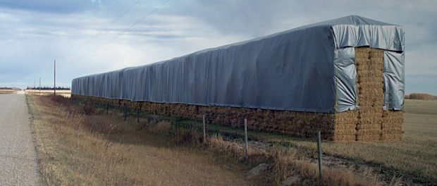
ST. JOSEPH, MICHIGAN, UNITED STATES, 2019-Aug-21 — /EPR Network/ — High demand for Hay Tarps and agricultural tarp coverings has proven to be a catalyst for expanding offerings of tarps and coverings used in the production of hay and other farm products. Noting that unprotected hay is subject to 25 percent loss due to weathering and exposure, Tarps Now has underwritten the manufacture high quality Heavy Duty Hay Tarps that feature reinforced poly material which are designed to be resistant to the effects of Ultra-Violet Radiation which has proven to reduce the total cost of ownership, as lower grade fabrics often used by farmers across North America were far less durable.
In addition to the premium grade of fabrics utilized, the agricultural tarp coverings manufactured by Tarps Now® also feature brass spur grommets every two feet and 2-inch loops of webbing every four feet along the perimeter. This proprietary design ensures long lasting durability due to secure fittings, as well as easy anchoring of ropes, spiral pins, pipes and posts.
Heavy Duty Farm Hay Tarps
Manufactured in the United States, Tarps Now® agricultural tarp coverings have a silver exterior to reflect sunlight and reduce interior heat. Not only do these agricultural tarps protect farm products from damaging outdoor elements; they also serve to organize and consolidate farm products, resulting in easier transport to indoor storage.
Tarps Now® Farming Tarp Products:
https://www.tarpsnow.com/hay-tarp.html
https://www.tarpsnow.com/heavy-duty-tarps.html
https://www.tarpsnow.com/heavy-duty-vinyl-tarps.html
https://www.tarpsnow.com/waterproof-canvas-tarps-breathable-tarps.html
https://www.tarpsnow.com/heavy-duty-poly-tarps.html
https://www.tarpsnow.com/heavy-duty-vinyl-mesh-tarps.html
https://www.tarpsnow.com/hypalon-tarps-csm-tarps.html
https://www.tarpsnow.com/neoprene-coated-nylon-tarps.html
https://www.tarpsnow.com/construction-tarps.html
https://www.tarpsnow.com/construction-tarps.html
https://www.tarpsnow.com/industrial-tarps.html
https://www.tarpsnow.com/industrial-covers.html
https://www.tarpsnow.com/truck-tarps.html
https://www.tarpsnow.com/airbag-tarps.html
https://www.tarpsnow.com/canvas-tarps.html
About Tarps Now®
Tarps Now® features an extensive online catalog of heavy duty tarps, canvas tarps, poly tarps, custom tarps, vinyl tarps and industrial divider curtains. As specialists in custom canvas and vinyl tarps, they are the low-price leaders in their category. The company offers the convenience of fast, easy, online ordering as well as a knowledgeable staff to guide customers through the specification process insuring their project will be completed on time and in budget. Tarps Now® has the experience and scale to insure customer specifications are carefully followed and expectations exceeded for every project, large or small.
Media contact:
Tarps Now, Inc.
4133 M-139
St Joseph, MI 49085
888-800-1383
sales@tarpsnow.com
https://www.tarpsnow.com
Logo:

Tarps Now logo
===
Press release distributed via EPR Network (http://express-press-release.net/submit-press-release.php)

