Tarps Now® Expands Concrete Curing Blanket Solutions for the Construction Industry

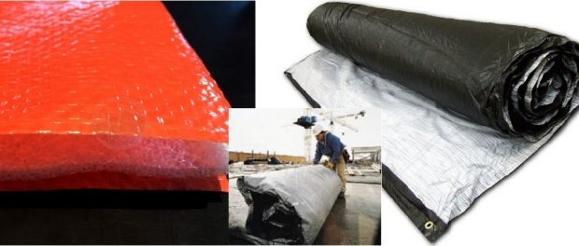
St. Joseph, Michigan, United States, 2019-Aug-22 — /EPR Network/ — Due to increasing demands of EPC Contractors and construction firms throughout North America, Tarps Now® is pleased to announce the addition of new lines of rugged concrete curing blankets engineered to meet the needs of the construction industry.
Tarps Now® manufactures its concrete curing blanket lines using the toughest woven polyethylene fabric and engineered for correct insulation and extended longevity. In addition, these new lines of concrete curing blankets using a flexible foam which provides the highest possible R value factor to accelerate the concrete curing process during all types of weather.
Being highly resilient and hydrophobic, the micro-foam selected by Tarps Now® during the manufacturing process ensures superior performance, with an outer poly outer shell that extremely durable and long lasting. Tarps Now® concrete curing blankets also feature a deep black on the exterior to provide maximum temperature gain from solar heat, thereby maximizing interior insulation layer R values ranging up to 7.7.
Supporting the new array of Concrete Curing Blankets offered, Tarps Now® provides a variety of stock or standard sizes of concrete curing blankets ranging from 12-mil, 1/2-inch closed cell measuring 3 x 25 feet to 12-mil, to 1/4-inch closed cell blankets that are 12 x 25 feet. Further, as a U.S.-based custom manufacturer of tarps, covers and insulated curing blankets, Tarps Now® produces custom concrete curing blankets sizes for any project. In addition, wet concrete blankets also are available for ordering where conditions warrant this type of use.
Tarps Now® Concrete Curing Blankets:
https://www.tarpsnow.com/concrete-curing-blankets.html
https://www.tarpsnow.com/concrete-curing-blanket-12-mil-3-4-thick.html
https://www.tarpsnow.com/concrete-curing-blanket-6-mil-r7-7-50-bundle.html
https://www.tarpsnow.com/concrete-curing-blanket-12-mil-1-2-thick.html
https://www.tarpsnow.com/concrete-curing-blanket-6-mil-r5-11-50-bundle.html
https://www.tarpsnow.com/concrete-curing-blanket-12-mil-1-4-thick.html
https://www.tarpsnow.com/concrete-curing-blanket-6-mil-r2-8-50-bundle.html
https://www.tarpsnow.com/insulated-tarps-6-x-25.html
https://www.tarpsnow.com/insulated-tarps-12-x-20.html
About Tarps Now®
Tarps Now® features an extensive online catalog of canvas tarps, poly tarps, custom tarps, vinyl tarps and industrial divider curtains. As specialists in custom canvas and vinyl tarps, they are the low-price leaders in their category. The company offers the convenience of fast, easy, online ordering as well as a knowledgeable staff to guide customers through the specification process insuring their project will be completed on time and in budget. Tarps Now® has the experience and scale to insure customer specifications are carefully followed and expectations exceeded for every project, large or small.
Media contact:
Michael Dill, CEO
Tarps Now, Inc.
4133 M-139
St Joseph, MI 49085
888-800-1383
sales@tarpsnow.com
https://www.tarpsnow.com
Logo:
Tarps Now logo

Press release distributed via EPR Network (http://express-press-release.net/submit-press-release.php)

