Tarps Now® Military Grade Tarps and Fabric Offerings

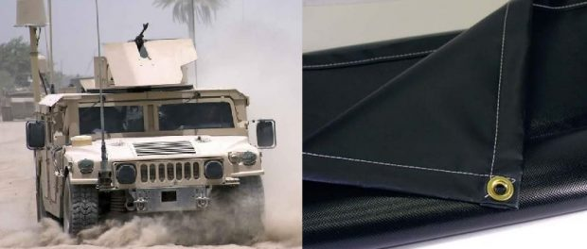Tarps Now® Military Grade Tarps and Fabric Offerings
St. Joseph, Michigan, United States, 2019-Aug-28 — /EPR Network/ — Due to increasing need for Military Grade tarps, covers and fabrics meeting the specifications of the military branches, as well as State, Federal and municipal governmental agencies, Tarps Now® is pleased to announce the release of military grade tarps and covers that are engineered to meet the specifications that includes A-A-55308, A-A-59403, A-A-59708, CCC-C-419, CCC-C-422, CCC-C-428, CCC-C-432, CCC-C-439, CCC-C-442, CCC-C-443, CCC-D-950, MIL-C-10799, MIL-C-20696, MIL-C-43006, MIL-C-43128, MIL-C-43627, MIL-C-44103, MIL-C-788, MIL-PRF-20696, A-A-59403, A-A-549403A.
In addition to the new lines meeting Military Tarp specifications, Tarps Now® is also pleased to announce the release of tarps and covers meeting the needs of the United States Forestry Service which includes: (5100-86), MIL-C-3953, MIL-C-7219, MIL-C-10799, MIL-C-12369, MIL-C-43128, MIL-C-43734, MIL-C-43734D, Class 3, MIL-C-43375, NFPA-701, SS-481, SS-482, CPAI-63, CPAI-84.
The new lines of military grade tarps and fabrics are Made in the USA and are engineered to cover sensitive equipment, create weather-resistance outdoor tents, and secure and protect large items during transportation. These high-quality military grade tarps and covers are flexible, waterproof and flame retardant, as well as resistant to tearing, abrasions and resistant to Ultra-Violet light damage. For applications requiring military grade fabric, rolls are now sold in lengths of 50 to hundred yards.
Tarps Now® Products:
https://www.tarpsnow.com/military-specification-fabric-by-the-yard-roll.html
https://www.tarpsnow.com/hypalon-tarps-csm-tarps.html
https://www.tarpsnow.com/custom-canvas-tarps-covers.html
https://www.tarpsnow.com/heavy-duty-tarps.html
https://www.tarpsnow.com/canvas-tarps.html
https://www.tarpsnow.com/clear-tarps.html
https://www.tarpsnow.com/poly-tarps.html
https://www.tarpsnow.com/vinyl-tarps.html
https://www.tarpsnow.com/neoprene-coated-nylon-tarps.html
https://www.tarpsnow.com/polyester-tarps-600-x-300-denier.html
https://www.tarpsnow.com/fire-resistant-tarps.html
https://www.tarpsnow.com/specialty-tarps.html
https://www.tarpsnow.com/tarp-products.html
About Tarps Now®
Tarps Now® features an extensive online catalog of canvas tarps, poly tarps, custom tarps, mesh tarps, vinyl tarps and industrial divider curtains. As specialists in custom, canvas and vinyl tarps, they are the low-price leaders in their category. The company offers the convenience of fast, easy, online ordering as well as a knowledgeable staff to guide customers through the specification process insuring their project will be completed on time and in budget. Tarps Now® has the experience and scale to insure customer specifications are carefully followed and expectations exceeded for every project, large or small.
Contact-Details:
Michael Dill, CEO
Tarps Now, Inc.
4133 M-139
St Joseph, MI 49085
888-800-1383
sales@tarpsnow.com
https://www.tarpsnow.com
Logo:
Tarps Now logo

Press release distributed via EPR Network (http://express-press-release.net/submit-press-release.php)

