Tarps Now® Offers New Lines of Shade Tarps to Reduce Dangerous Exposure to Sunlight

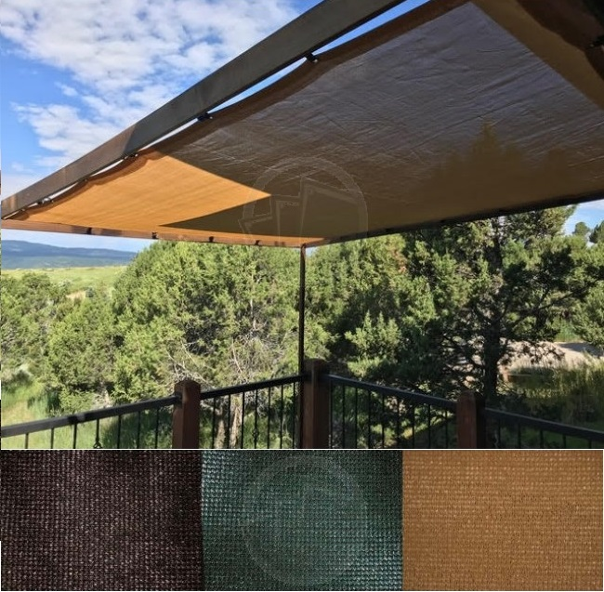
Tarps Now® Offers New Lines of Shade Tarps to Reduce Dangerous Exposure to Sunlight
St. Joseph, Michigan, United States, 2019-Aug-30 — /EPR Network/ — Tarps Now® is pleased to announce new lines of outdoor Shade Tarps that reduces exposure to the effects of intense sunlight and other forms of ultraviolet radiation linked to skin cancers in both humans and animals.
To meet the need for protective coverings around homes, animal habitats and other outdoor structures, Tarps Now custom manufactures protective shade tarps and other mesh coverings in a variety of exposure ratings, weights, fabric grades and colors that are engineered to provide outstanding levels of protection.
Applications for these new lines of Shade Tarps extends to uses such as patios, decks, thresholds, gazebos, pools, picnic areas, barns, kennels and other outdoor recreational areas.
Conversely, many businesses are adopting the use of Sun Shade Tarps to protect businesses and their employees who work in areas where prolonged exposure to the elements exists such as in agricultural processing areas, warehousing docks, shipping and receiving areas, and many other outdoor areas where such applications reduces exposure to extreme sunlight exposure and potential heatstroke.
Tarps Now® recognizes that different habitats require different exposure levels, and thus offers a complete line up of Shade Tarps properly rated to meet individual needs.
Tarps Now® Shade Tarp by Exposure Levels:
https://www.tarpsnow.com/mesh-shade-tarps.html
https://www.tarpsnow.com/shade-tarps-polypro-mesh-95.html 95% Exposure
https://www.tarpsnow.com/86-knitted-shade-mesh-tarps.html 86% Exposure
https://www.tarpsnow.com/polypro-mesh-shade-tarps-70.html 70% Exposure
https://www.tarpsnow.com/polypro-mesh-shade-tarps-60.html 60% Exposure
https://www.tarpsnow.com/polypro-mesh-shade-tarps-50.html 50% Exposure
https://www.tarpsnow.com/polypro-mesh-shade-tarps-50.html 40% Exposure
https://www.tarpsnow.com/specialty-tarps.html
https://www.tarpsnow.com/tarp-products.html
About Tarps Now®
Tarps Now® features an extensive online catalog of canvas tarps, poly tarps, custom tarps, vinyl tarps and industrial divider curtains. As specialists in custom canvas and vinyl tarps, they are the low-price leaders in their category. The company offers the convenience of fast, easy, online ordering as well as a knowledgeable staff to guide customers through the specification process insuring their project will be completed on time and in budget. Tarps Now® has the experience and scale to insure customer specifications are carefully followed and expectations exceeded for every project, large or small.
Contact-Details:
Michael Dill, CEO
Tarps Now, Inc.
4133 M-139
St Joseph, MI 49085
888-800-1383
sales@tarpsnow.com
https://www.tarpsnow.com
Logo:
Tarps Now logo
===
Press release distributed via EPR Network (http://express-press-release.net/submit-press-release.php)

