Hurricane Dorian Increases Demand for Hurricane Tarps used in Disaster Recovery

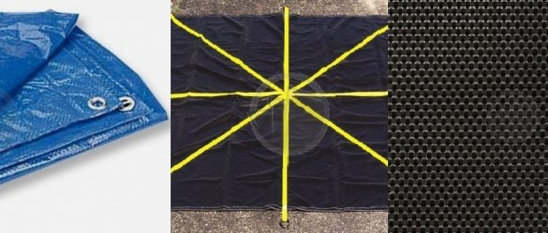
St. Joseph, Michigan, United States, 2019-Sep-04 — /EPR Network/ — In the wake of storm surges of up to 18 feet on Grand Bahama Island, Hurricane Dorian continues threatens residents of the Florida coastline, as well as Georgia, South Carolina, North Carolina and Southeastern Virginia coastlines, with the potential for high winds, heavy rains and storm surge.
While Dorian has been downgraded to a Category 2 Hurricane, municipalities, non-profit organizations, businesses and homeowners have begun stockpiling hurricane tarps, roofing tarps, mesh tarps, debris lifting tarps and tarp fabrics that help mitigate storm damage. Tarps are often used to immediately cover damaged roofing areas, broken windows and doors, as well as used to move debris, provide for water capture, sunscreen and shade, debris lifting, protective coverings and many other uses that protect homes, businesses, livestock and pets following hurricanes and tropical storms.
Noting the dramatic changes in weather closely linked to climate change, Tarps Now® has focused on providing protective tarps and coverings critical to hurricanes and tropical storms common to the Caribbean and the Eastern Seaboard. In addition, Tarps Now® also custom fabricates tarps prefabricated for mitigating damage to homes and other outdoor structures. The company also encourages the use of protective mesh tarp coverings that come in a wide range of different screen factors, weights, fabric grades and colors that are specifically engineered to deliver varying levels of UV protection and wind resistance, depending on the selected material and design, to better support evaporation.
Tarps Now® Recommended Hurricane and Storm Recovery Products:
https://www.tarpsnow.com/hurricane-mesh-barrier-tarps.html
https://www.tarpsnow.com/heavy-duty-tarps.html
https://www.tarpsnow.com/drain-tarps-leak-diverters.html
https://www.tarpsnow.com/canvas-tarps.html
https://www.tarpsnow.com/roof-debris-lifting-tarps.html
https://www.tarpsnow.com/construction-tarps.html
https://www.tarpsnow.com/mesh-tarps.html
https://www.tarpsnow.com/salvage-covers-and-tarps.html
https://www.tarpsnow.com/poly-tarps.html
https://www.tarpsnow.com/shade-tarps.html
https://www.tarpsnow.com/vinyl-tarps.html
https://www.tarpsnow.com/specialty-tarps.html
https://www.tarpsnow.com/tarp-products.html
About Tarps Now®
Tarps Now® features an extensive online catalog of canvas tarps, poly tarps, custom tarps, vinyl tarps and industrial divider curtains. As specialists in custom canvas and vinyl tarps, they are the low-price leaders in their category. The company offers the convenience of fast, easy, online ordering as well as a knowledgeable staff to guide customers through the specification process insuring their project will be completed on time and in budget. Tarps Now® has the experience and scale to insure customer specifications are carefully followed and expectations exceeded for every project, large or small.
Contact-Details:
Michael Dill, CEO
Tarps Now, Inc.
4133 M-139
St Joseph, MI 49085
888-800-1383
sales@tarpsnow.com
https://www.tarpsnow.com
Logo:
Tarps Now logo
===
Press release distributed via EPR Network (http://express-press-release.net/submit-press-release.php)

