Tarps Now® Increases Merchandising Options Supporting the EPC Construction Industry
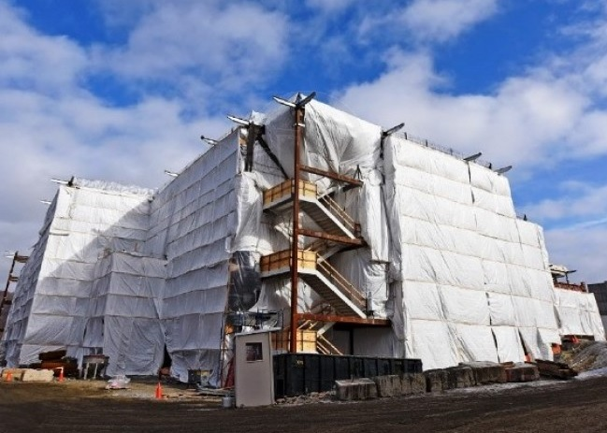
St. Joseph, Michigan, United States, 2019-Sep-11 — /EPR Network/ — Tarps Now® is pleased to announce increased commitment to Heavy Duty Tarps and Covers expanding the number of lines of heavy tarps and coverings engineered to meet the needs of Engineering, Procurement and Construction (“EPC”) contractors engaged in large scale projects throughout North America.
Noting the sustained growth in demand for high quality tarps in the construction marketplace, EPC Contractors who are actively engaged in completing turn key projects actively seek out the services of Tarps Now® for both stock sized tarp products, as well as a wide range of custom tarps covering products used in demolition, sandblasting, construction scaffolding, concrete curing, painting and finishing a wide range of projects serving heavy industry, electric and gas utilities, oil and gas pipelines, retail shopping centers, multi-family community projects, and healthcare industry facility projects.
Tarps Now® has invested in advanced technologies used to custom engineer and fabricate tarps products in an “on demand” modality. As a result of these investments, EPC Contractors benefit from accurate cost quotes, rapid order processing, engineering, fabrication and deliveries of high-quality, industrial grade tarp and covering products both on site and to EPC Contractor warehousing facilities as desired. Examples of tarps and covering used by EPC Contractors are as follows below.
Frequently Used EPC Contractor Products.
https://www.tarpsnow.com/construction-tarps.html
https://www.tarpsnow.com/concrete-curing-blankets.html
https://www.tarpsnow.com/debris-scaffold-debris-netting.html
https://www.tarpsnow.com/containment-sandblasting-mesh-barrier-fr.html
https://www.tarpsnow.com/debris-lifting-tarp-snow-tarps.html
https://www.tarpsnow.com/drain-tarps-leak-diverters.html
https://www.tarpsnow.com/geotextile-mesh-screens.html
https://www.tarpsnow.com/airbag-tarps.html
https://www.tarpsnow.com/salvage-covers-and-tarps.html
https://www.tarpsnow.com/painters-drop-cloths.html
https://www.tarpsnow.com/heavy-duty-tarps.html
https://www.tarpsnow.com/heavy-duty-vinyl-tarps.html
https://www.tarpsnow.com/waterproof-canvas-tarps-breathable-tarps.html
https://www.tarpsnow.com/heavy-duty-poly-tarps.html
https://www.tarpsnow.com/heavy-duty-vinyl-mesh-tarps.html
https://www.tarpsnow.com/hypalon-tarps-csm-tarps.html
https://www.tarpsnow.com/neoprene-coated-nylon-tarps.html
https://www.tarpsnow.com/industrial-tarps.html
https://www.tarpsnow.com/industrial-covers.html
https://www.tarpsnow.com/canvas-tarps.html
https://www.tarpsnow.com/custom-fence-screen.html
About Tarps Now®
Tarps Now® features an extensive online catalog of heavy duty tarps, canvas tarps, poly tarps, custom tarps, vinyl tarps and industrial divider curtains. As specialists in custom canvas and vinyl tarps, they are the low-price leaders in their category. The company offers the convenience of fast, easy, online ordering as well as a knowledgeable staff to guide customers through the specification process insuring their project will be completed on time and in budget. Tarps Now® has the experience and scale to insure customer specifications are carefully followed and expectations exceeded for every project, large or small.
Contact-Details:
Michael Dill, CEO
Tarps Now, Inc.
4133 M-139
St Joseph, MI 49085
888-800-1383
sales@tarpsnow.com
https://www.tarpsnow.com
Logo:
Tarps Now logo
Press release distributed via EPR Network (http://express-press-release.net/submit-press-release.php)

