Tarps Now® Announces New Storm Recovery Materials

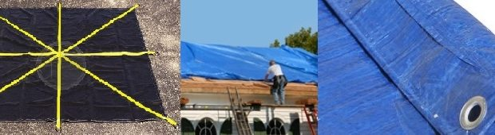
St. Joseph, Michigan, United States, 2019-Sep-24 — /EPR Network/ — When natural disasters strike, homes are destroyed, jobs and lives are lost, and local economies are decimated. Even when limited storm or earthquake damage causes damage to roofing, windows, interior rooms and thresholds, ready access to heavy duty tarps can quickly provide coverage that enhances the ability to effect lasting repairs while preserving things that have not been destroyed.
To meet the ever-increasing number of natural disasters associated with climate change, leading U.S. based tarp materials supplier, Tarps Now® has substantially increased its supplies of Super Heavy Duty Tarps in anticipation of future hurricanes and other types of natural disasters that are becoming all too common in the Western Hemisphere. Prompt access to heavy duty tarps in disaster prone areas has helped to provide temporary shelter when homes were nearly destroyed, and when they were not, these same tarps were used to secure damaged roofing areas, walls and interior rooms as well. These are also often used to quickly set up tents that delivered immediate protection from the elements. In addition, debris netting tarps are often used to cover areas where inclement weather makes repairs difficult to execute.
Tarps Now® offers their heavy-duty tarp products for sale to the public, businesses, state, federal, military and other governmental agencies through the TarpsNow.com website, which also provides tarp material consulting services to such entities throughout the Western Hemisphere. In addition, the company offers custom tarp fabricating through streamlined technology processes which is engineered to meet the needs of government, business and the private sector in record times.
Tarps Now® Disaster Recovery Products:
https://www.tarpsnow.com/custom-tarps-made.html
https://www.tarpsnow.com/40-oz-vinyl-coated-tarps-extreme-duty.html
https://www.tarpsnow.com/heavy-duty-tarps.html
https://www.tarpsnow.com/roofing-tarps.html
https://www.tarpsnow.com/canvas-tarps.html
https://www.tarpsnow.com/mesh-tarps.html
https://www.tarpsnow.com/poly-tarps.html
https://www.tarpsnow.com/vinyl-tarps.html
https://www.tarpsnow.com/fire-resistant-tarps.html
https://www.tarpsnow.com/specialty-tarps.html
https://www.tarpsnow.com/tarp-products.html
https://www.tarpsnow.com/debris-scaffold-debris-netting.html
https://www.tarpsnow.com/7-9-oz-hurricane-trampoline-mesh-tarps.html
About Tarps Now®
Tarps Now® features an extensive online catalog of canvas tarps, poly tarps, custom tarps and covers, mesh tarps, vinyl tarps and industrial divider curtains. As specialists in custom, canvas and vinyl tarps, they are the low-price leaders in their category. The company offers the convenience of fast, easy, online ordering as well as a knowledgeable staff to guide customers through the specification process insuring their project will be completed on time and in budget. Tarps Now® has the experience and scale to insure customer specifications are carefully followed and expectations exceeded for every project, large or small.
Contact-Details:
Tarps Now, Inc.
4133 M-139
St Joseph, MI 49085
1-888-800-1383
sales@tarpsnow.com
www.tarpsnow.com
Logo:
Tarps Now logo

Press release distributed via EPR Network (http://express-press-release.net/submit-press-release.php)

