Travel Packages to Masai Mara View Wildlife by Cruzeiro Safaris Kenya
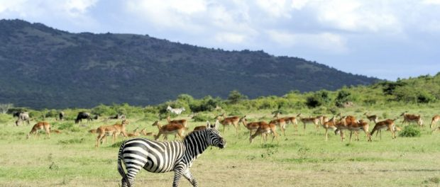
Masai Mara National Reserve rare spotting of baby zebra in Kenya
NAIROBI, Kenya, 2019-Sep-26 — /EPR Network/ — The baby zebra is being known as ‘blacker’ beautiful shade of black spots shades unlike the normal stripped zebra.
Also known as ‘polka’ the cross – breed zebra goes viral on the internet with Kenyans excited to view it in the Masai Mara.
How to get to Masai mara
Step 1, 2 and 3 contact Cruzeiro Safaris Kenya for tailored safaris or book online through their website
Masai Mara Safari by Road
Book Direct to Masai Mara Safaris by Air
About Cruzeiro Safaris Kenya
Cruzeiro-safaris.com is established in Kenya, incorporated in 2004. Its core business is safari packages and day tours complemented by air travel. It has a well-established wealth of experience in arranging memorable tours and safaris and has established a client base who provide with repeat business year after year. Join us on facebook, twitter and youtube. Safaris in Kenya may be tailored to the tourist taste and can extend to Tanzania and Uganda. Browse and read reviews on tripadvisor page and one can also book from tripadvisor link.
Contact-Details:
Claudia Kabui
Mobile : +254-(0) 722-370833 (Kenya)
Sales: + 254 (0) 710-729021 (Kenya)
Email: info@cruzeiro-safaris.com
Website: | https://www.cruzeiro-safaris.com and https://cruzeiro-safaris.com/nairobi-tours/
Press release distributed via EPR Network (http://express-press-release.net/submit-press-release.php)

